INDEX

TOPICS

- Certificates………………………………………………………………………………………
- Acknowledgement…………………………………………………………………………........
CHAPTER 1: INTRODUCTION

  - Introduction of the project …………………………………………………………………………………
  - Project overview……………………………………………………………………………………………...
  - Thesis…………………………………………………………………………………………………………

CHAPTER 2: EMBEDDED SYSTEMS

2.1 Introduction to embedded systems…………………………………………………………………………
2.2 Need of embedded systems…………………………………………………………………………………...
2.3 Explanation of embedded systems…………………………………………………………………………...
2.4 Applications of embedded systems…………………………………………………………………………

CHAPTER 3: HARDWARE DESCRIPTION

3.1 Introduction with block diagram……………………………………………………………
3.2 ARDUINO UNO microcontroller……………………………………………………………
3.3 Regulated power supply………………………………………………………………………
3.4 LED indicator……………………………………………………………………………………
3.5 Wi-Fi module………………….…..……………………………….……………………………
3.6 Heart beat pulse sensor…………………………………………………………………………
3.7 Temperature sensor…..……………………………………………………………………………
3.8 Buzzer………………………………………………………………………………………………
3.9 LCD display…………………………………………………………………………………….
3.10 Keypad……………………………………………………………………………………………….

CHAPTER 4: SOFTWARE DESCRIPTION

4.1 Express PCB…………………………………………………………………………………………………
4.2 Arduino Studio IDE ……………………………………………………………………………………….
4.3 Proteus software………………………………………………………………………………………………
4.4 Procedural steps for compilation, simulation and dumping……………………………………..
4.5 MATLAB software…………………………………………………………………………………
CHAPTER 5: PROJECT DESCRIPTION

CHAPTER 6: ADVANTAGES, DISADVANTAGES AND APPLICATIONS

CHAPTER 7: RESULTS, CONCLUSION, FUTURE PROSPECTS

REFERENCES

CHAPTER 1: INTRODUCTION
1.1 Introduction:

When a major operation is carried out, Anesthesia must be given to the patient. Sometimes it happens that estimated duration of the operation may get extended. This extension can be up to 4 to 6 hours, where anesthetists cannot judge the level of overall Anesthesia required. Anesthesia infusion is a closed loop system, in which an aesthesiologist follow the process of anticipating the predicted dose. To figure out appropriate dose, one needs to continuously monitor different physiological parameters. To handle and overcome such a situation, anesthetists assigned to observe the level of anesthesia, failing to do so may occur other consequences. To avoid such unpredictable situation, the scheme of smart anesthesia syringe is helpful.
The system consists of microcontroller and an injector infusion pump along with thread screw mechanism. The level of anesthesia is decided based on the results of different sensors. The anesthesia will be monitoring the health parameters such as heartbeat and temperature on LCD display. In this by using keypad we can enter the anesthesia levels to the microcontroller. Once the level of anesthesia is configured by the machine, it will work accordingly. We can set the maximum limit of anesthesia using limit switch. The main controlling device of the project is Arduino uno, to achieve this task microcontroller loaded program written in embedded c language.

Objective of the project:
- It mainly helps in medical industries in performing major surgeries which takes place longer time durations.
- Here we use embedded systems which help us in solving associative problems and provide accurate drug dosages.
- Many parameters are taken into consideration to reduce the errors and increase the efficiency of the system.
- Keypad based dynamic level setting of Anesthesia.
- Design an Anesthesia syringe along with heartbeat and temperature monitoring system.

1.2 Project Overview:
An embedded system is a combination of software and hardware to perform a dedicated task. Some of the main devices used in embedded products are Microprocessors and AVR microcontrollers.
Microprocessors are commonly referred to as general purpose processors as they simply accept the inputs, process it and give the output. In contrast, an AVR microcontroller not only accepts the data as inputs but also manipulates it, interfaces the data with various devices, controls the data and thus finally gives the result.
The project “Smart Anesthesia Syringe” using arduino uno is an exclusive project that can provide the health parameters such as heartbeat and temperature of the person on LCD module and also that can injects the anesthesia as per user request using keypad.
1.3 Thesis:
The thesis explains the implementation of “Smart Anesthesia Syringe” using Arduino UNO microcontroller. The organization of the thesis is explained here with:
Chapter 1 Presents introduction to the overall thesis and the overview of the project. In the project overview a brief introduction of Anesthesia Syringe, heartbeat, temperature, keypad and LCD display and its applications are discussed.
Chapter 2 Presents the topic embedded systems. It explains the about what is embedded systems, need for embedded systems, explanation of it along with its applications.
Chapter 3 Presents the hardware description. It deals with the block diagram of the project and explains the purpose of each block. In the same chapter the explanation of each module considered.
Chapter 4 Presents the software description. It explains the implementation of the project using Arduino Studio IDE Compiler software.
Chapter 5 Presents the project description along with each module interfacing to microcontroller.
Chapter 6 Presents the advantages, disadvantages and applications of the project.
Chapter 7 Presents the results, conclusion and future scope of the project.

CHAPTER 2: EMBEDDED SYSTEMS
2.1 Embedded Systems:
An embedded system is a computer system designed to perform one or a few dedicated functions often with real-time computing constraints. It is embedded as part of a complete device often including hardware and mechanical parts. By contrast, a general-purpose computer, such as a personal computer (PC), is designed to be flexible and to meet a wide range of end-user needs. Embedded systems control many devices in common use today.
Embedded systems are controlled by one or more main processing cores that are typically either AVR microcontrollers or digital signal processors (DSP). The key characteristic, however, is being dedicated to handle a particular task, which may require very powerful processors. For example, air traffic control systems may usefully be viewed as embedded, even though they involve mainframe computers and dedicated regional and national networks between airports and radar sites. (Each radar probably includes one or more embedded systems of its own.)
Since the embedded system is dedicated to specific tasks, design engineers can optimize it to reduce the size and cost of the product and increase the reliability and performance. Some embedded systems are mass-produced, benefiting from economies of scale.
Physically embedded systems range from portable devices such as digital watches and MP3 players, to large stationary installations like traffic lights, factory controllers, or the systems controlling nuclear power plants. Complexity varies from low, with a single AVR microcontroller chip, to very high with multiple units, peripherals and networks mounted inside a large chassis or enclosure.
In general, "embedded system" is not a strictly definable term, as most systems have some element of extensibility or programmability. For example, handheld computers share some elements with embedded systems such as the operating systems and microprocessors which power them, but they allow different applications to be loaded and peripherals to be connected. Moreover, even systems which don't expose programmability as a primary feature generally need to support software updates. On a continuum from "general purpose" to "embedded", large application systems will have subcomponents at most points even if the system as a whole is "designed to perform one or a few dedicated functions", and is thus appropriate to call "embedded". A modern example of embedded system is shown in fig: 2.1.
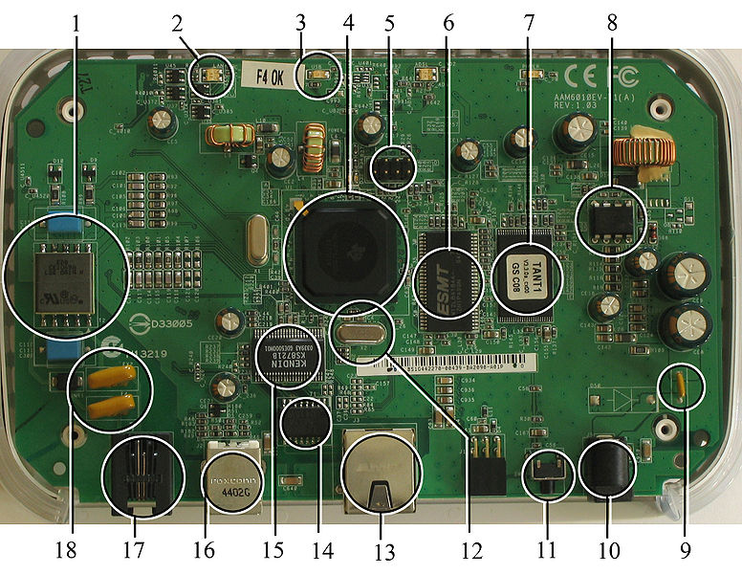
Fig 2.1:A modern example of embedded system
Labeled parts include microprocessor (4), RAM (6), flash memory (7).Embedded systems programming is not like normal PC programming. In many ways, programming for an embedded system is like programming PC 15 years ago. The hardware for the system is usually chosen to make the device as cheap as possible. Spending an extra dollar a unit in order to make things easier to program can cost millions. Hiring a programmer for an extra month is cheap in comparison. This means the programmer must make do with slow processors and low memory, while at the same time battling a need for efficiency not seen in most PC applications. Below is a list of issues specific to the embedded field.
2.1.1 History:
In the earliest years of computers in the 1930–40s, computers were sometimes dedicated to a single task, but were far too large and expensive for most kinds of tasks performed by embedded computers of today. Over time however, the concept of programmable controllers evolved from traditional electromechanical sequencers, via solid state devices, to the use of computer technology.
One of the first recognizably modern embedded systems was the Apollo Guidance Computer, developed by Charles Stark Draper at the MIT Instrumentation Laboratory. At the project's inception, the Apollo guidance computer was considered the riskiest item in the Apollo project as it employed the then newly developed monolithic integrated circuits to reduce the size and weight. An early mass-produced embedded system was the Autonetics D-17 guidance computer for the Minuteman missile, released in 1961. It was built from transistor logic and had a hard disk for main memory. When the Minuteman II went into production in 1966, the D-17 was replaced with a new computer that was the first high-volume use of integrated circuits.
2.1.2 Tools:
Embedded development makes up a small fraction of total programming. There's also a large number of embedded architectures, unlike the PC world where 1 instruction set rules, and the Unix world where there's only 3 or 4 major ones. This means that the tools are more expensive. It also means that they're lowering featured, and less developed. On a major embedded project, at some point you will almost always find a compiler bug of some sort.
Debugging tools are another issue. Since you can't always run general programs on your embedded processor, you can't always run a debugger on it. This makes fixing your program difficult. Special hardware such as JTAG ports can overcome this issue in part. However, if you stop on a breakpoint when your system is controlling real world hardware (such as a motor), permanent equipment damage can occur. As a result, people doing embedded programming quickly become masters at using serial IO channels and error message style debugging.
2.1.3 Resources:
To save costs, embedded systems frequently have the cheapest processors that can do the job. This means your programs need to be written as efficiently as possible. When dealing with large data sets, issues like memory cache misses that never matter in PC programming can hurt you. Luckily, this won't happen too often- use reasonably efficient algorithms to start, and optimize only when necessary. Of course, normal profilers won't work well, due to the same reason debuggers don't work well.
Memory is also an issue. For the same cost savings reasons, embedded systems usually have the least memory they can get away with. That means their algorithms must be memory efficient (unlike in PC programs, you will frequently sacrifice processor time for memory, rather than the reverse). It also means you can't afford to leak memory. Embedded applications generally use deterministic memory techniques and avoid the default "new" and "malloc" functions, so that leaks can be found and eliminated more easily. Other resources programmers expect may not even exist. For example, most embedded processors do not have hardware FPUs (Floating-Point Processing Unit). These resources either need to be emulated in software, or avoided altogether.
2.1.4 Real Time Issues:
Embedded systems frequently control hardware, and must be able to respond to them in real time. Failure to do so could cause inaccuracy in measurements, or even damage hardware such as motors. This is made even more difficult by the lack of resources available. Almost all embedded systems need to be able to prioritize some tasks over others, and to be able to put off/skip low priority tasks such as UI in favor of high priority tasks like hardware control.
2.2 Need For Embedded Systems:
The uses of embedded systems are virtually limitless, because every day new products are introduced to the market that utilizes embedded computers in novel ways. In recent years, hardware such as microprocessors, AVR microcontrollers, and FPGA chips have become much cheaper. So when implementing a new form of control, it's wiser to just buy the generic chip and write your own custom software for it. Producing a custom-made chip to handle a particular task or set of tasks costs far more time and money. Many embedded computers even come with extensive libraries, so that "writing your own software" becomes a very trivial task indeed. From an implementation viewpoint, there is a major difference between a computer and an embedded system. Embedded systems are often required to provide Real-Time response. The main elements that make embedded systems unique are its reliability and ease in debugging.
2.2.1 Debugging:
Embedded debugging may be performed at different levels, depending on the facilities available. From simplest to most sophisticate they can be roughly grouped into the following areas:
- Interactive resident debugging, using the simple shell provided by the embedded operating system (e.g. Forth and Basic)
- External debugging using logging or serial port output to trace operation using either a monitor in flash or using a debug server like the Remedy Debugger which even works for heterogeneous multi core systems.
- An in-circuit debugger (ICD), a hardware device that connects to the microprocessor via a JTAG or Nexus interface. This allows the operation of the microprocessor to be controlled externally, but is typically restricted to specific debugging capabilities in the processor.
- An in-circuit emulator replaces the microprocessor with a simulated equivalent, providing full control over all aspects of the microprocessor.
- A complete emulator provides a simulation of all aspects of the hardware, allowing all of it to be controlled and modified and allowing debugging on a normal PC.
- Unless restricted to external debugging, the programmer can typically load and run software through the tools, view the code running in the processor, and start or stop its operation. The view of the code may be as assembly code or source-code.
Because an embedded system is often composed of a wide variety of elements, the debugging strategy may vary. For instance, debugging a software(and microprocessor) centric embedded system is different from debugging an embedded system where most of the processing is performed by peripherals (DSP, FPGA, co-processor). An increasing number of embedded systems today use more than one single processor core. A common problem with multi-core development is the proper synchronization of software execution. In such a case, the embedded system design may wish to check the data traffic on the busses between the processor cores, which requires very low-level debugging, at signal/bus level, with a logic analyzer, for instance.
2.2.2 Reliability:
Embedded systems often reside in machines that are expected to run continuously for years without errors and in some cases recover by themselves if an error occurs. Therefore the software is usually developed and tested more carefully than that for personal computers, and unreliable mechanical moving parts such as disk drives, switches or buttons are avoided.
Specific reliability issues may include:
- The system cannot safely be shut down for repair, or it is too inaccessible to repair. Examples include space systems, undersea cables, navigational beacons, bore-hole systems, and automobiles.
- The system must be kept running for safety reasons. "Limp modes" are less tolerable. Often backups are selected by an operator. Examples include aircraft navigation, reactor control systems, safety-critical chemical factory controls, train signals, engines on single-engine aircraft.
- The system will lose large amounts of money when shut down: Telephone switches, factory controls, bridge and elevator controls, funds transfer and market making, automated sales and service.
A variety of techniques are used, sometimes in combination, to recover from errors—both software bugs such as memory leaks, and also soft errors in the hardware:
- Watchdog timer that resets the computer unless the software periodically notifies the watchdog
- Subsystems with redundant spares that can be switched over to
- software "limp modes" that provide partial function
- Designing with a Trusted Computing Base (TCB) architecture[6] ensures a highly secure & reliable system environment
- An Embedded Hypervisor is able to provide secure encapsulation for any subsystem component, so that a compromised software component cannot interfere with other subsystems, or privileged-level system software. This encapsulation keeps faults from propagating from one subsystem to another, improving reliability. This may also allow a subsystem to be automatically shut down and restarted on fault detection.
- Immunity Aware Programming
2.3 Explanation of Embedded Systems:
2.3.1 Software Architecture:
There are several different types of software architecture in common use.
- Simple Control Loop:
In this design, the software simply has a loop. The loop calls subroutines, each of which manages a part of the hardware or software.
- Interrupt Controlled System:
Some embedded systems are predominantly interrupt controlled. This means that tasks performed by the system are triggered by different kinds of events. An interrupt could be generated for example by a timer in a predefined frequency, or by a serial port controller receiving a byte. These kinds of systems are used if event handlers need low latency and the event handlers are short and simple.
Usually these kinds of systems run a simple task in a main loop also, but this task is not very sensitive to unexpected delays. Sometimes the interrupt handler will add longer tasks to a queue structure. Later, after the interrupt handler has finished, these tasks are executed by the main loop. This method brings the system close to a multitasking kernel with discrete processes.
- Cooperative Multitasking:
A non-preemptive multitasking system is very similar to the simple control loop scheme, except that the loop is hidden in an API. The programmer defines a series of tasks, and each task gets its own environment to “run” in. When a task is idle, it calls an idle routine, usually called “pause”, “wait”, “yield”, “nop” (stands for no operation), etc.The advantages and disadvantages are very similar to the control loop, except that adding new software is easier, by simply writing a new task, or adding to the queue-interpreter.
- Primitive Multitasking:
In this type of system, a low-level piece of code switches between tasks or threads based on a timer (connected to an interrupt). This is the level at which the system is generally considered to have an "operating system" kernel. Depending on how much functionality is required, it introduces more or less of the complexities of managing multiple tasks running conceptually in parallel.
As any code can potentially damage the data of another task (except in larger systems using an MMU) programs must be carefully designed and tested, and access to shared data must be controlled by some synchronization strategy, such as message queues, semaphores or a non-blocking synchronization scheme.
Because of these complexities, it is common for organizations to buy a real-time operating system, allowing the application programmers to concentrate on device functionality rather than operating system services, at least for large systems; smaller systems often cannot afford the overhead associated with a generic real time system, due to limitations regarding memory size, performance, and/or battery life.
- Microkernels And Exokernels:
A microkernel is a logical step up from a real-time OS. The usual arrangement is that the operating system kernel allocates memory and switches the CPU to different threads of execution. User mode processes implement major functions such as file systems, network interfaces, etc.
In general, microkernels succeed when the task switching and intertask communication is fast, and fail when they are slow. Exokernels communicate efficiently by normal subroutine calls. The hardware and all the software in the system are available to, and extensible by application programmers. Based on performance, functionality, requirement the embedded systems are divided into three categories:
2.3.2 Stand Alone Embedded System:
These systems takes the input in the form of electrical signals from transducers or commands from human beings such as pressing of a button etc.., process them and produces desired output. This entire process of taking input, processing it and giving output is done in standalone mode. Such embedded systems comes under stand alone embedded systems
Eg: microwave oven, air conditioner etc..
2.3.3 Real-time embedded systems:
Embedded systems which are used to perform a specific task or operation in a specific time period those systems are called as real-time embedded systems. There are two types of real-time embedded systems.
- Hard Real-time embedded systems:
These embedded systems follow an absolute dead line time period i.e.., if the tasking is not done in a particular time period then there is a cause of damage to the entire equipment.
Eg: consider a system in which we have to open a valve within 30 milliseconds. If this valve is not opened in 30 ms this may cause damage to the entire equipment. So in such cases we use embedded systems for doing automatic operations.
- Soft Real Time embedded systems:
These embedded systems follow a relative dead line time period i.e.., if the task is not done in a particular time that will not cause damage to the equipment.
Eg: Consider a TV remote control system, if the remote control takes a few milliseconds delay it will not cause damage either to the TV or to the remote control. These systems which will not cause damage when they are not operated at considerable time period those systems comes under soft real-time embedded systems.
2.3.4 Network communication embedded systems:
A wide range network interfacing communication is provided by using embedded systems.
Eg:
- Consider a web camera that is connected to the computer with internet can be used to spread communication like sending pictures, images, videos etc.., to another computer with internet connection throughout anywhere in the world.
- Consider a web camera that is connected at the door lock.
Whenever a person comes near the door, it captures the image of a person and sends to the desktop of your computer which is connected to internet. This gives an alerting message with image on to the desktop of your computer, and then you can open the door lock just by clicking the mouse. Fig: 2.2 show the network communications in embedded systems.
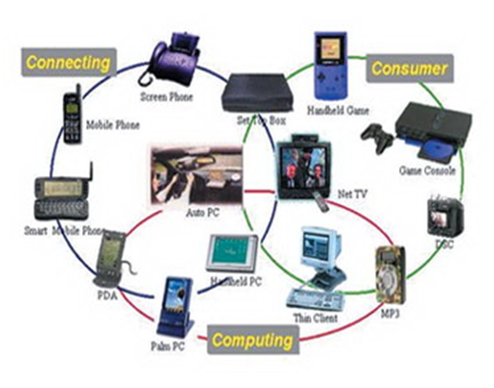
Fig 2.2: Network communication embedded systems
2.3.5 Different types of processing units:
The central processing unit (c.p.u) can be any one of the following microprocessor, AVR microcontroller, digital signal processing.
- Among these AVR microcontroller is of low cost processor and one of the main advantage of AVR microcontrollers is, the components such as memory, serial communication interfaces, analog to digital converters etc.., all these are built on a single chip. The numbers of external components that are connected to it are very less according to the application.
- Microprocessors are more powerful than AVR microcontrollers. They are used in major applications with a number of tasking requirements. But the microprocessor requires many external components like memory, serial communication, hard disk, input output ports etc.., so the power consumption is also very high when compared to AVR microcontrollers.
- Digital signal processing is used mainly for the applications that particularly involved with processing of signals
2.4 APPLICATIONS OF EMBEDDED SYSTEMS:
2.4.1 Consumer applications:
At home we use a number of embedded systems which include microwave oven, remote control, vcd players, dvd players, camera etc….
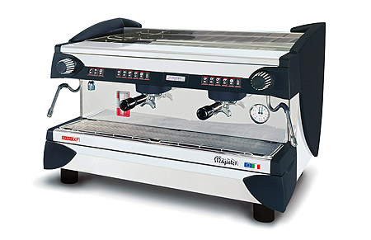
Fig2.3: Automatic coffee makes equipment
2.4.2 Office automation:
We use systems like fax machine, modem, printer etc…
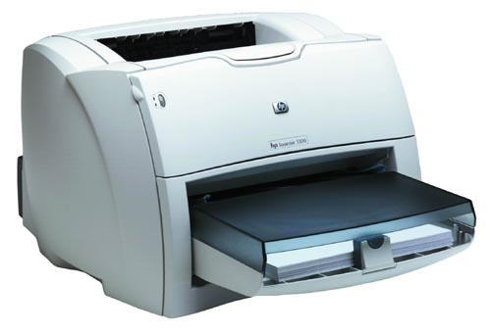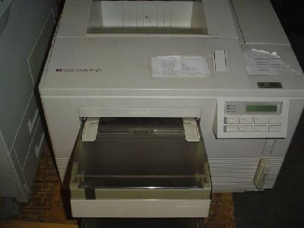
Fig2.4: Fax machine Fig2.5: Printing machine

2.4.3. Industrial automation:

Today a lot of industries are using embedded systems for process control. In industries we design the embedded systems to perform a specific operation like monitoring temperature, pressure, humidity ,voltage, current etc.., and basing on these monitored levels we do control other devices, we can send information to a centralized monitoring station.

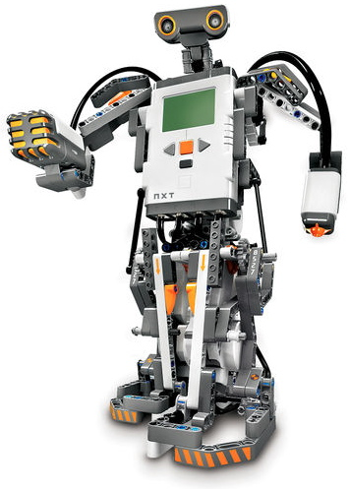
Fig2.6: Robot
In critical industries where human presence is avoided there we can use robots which are programmed to do a specific operation.
2.4.5 Computer networking:
Embedded systems are used as bridges routers etc..
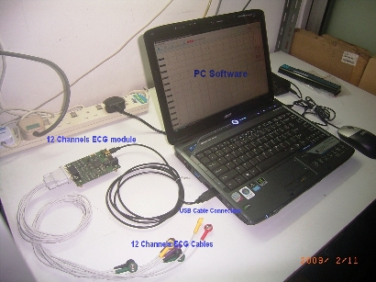
Fig2.7: Computer networking

2.4.6 Tele communications:

Cell phones, web cameras etc.
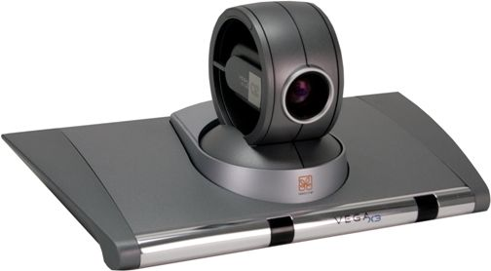
Fig2.8: Cell Phone Fig2.9: Web camera

CHAPTER 3: HARDWARE DESCRIPTION

3.1 Introduction:
In this chapter the block diagram of the project and design aspect of independent modules are considered. Block diagram is shown in fig: 3.1:
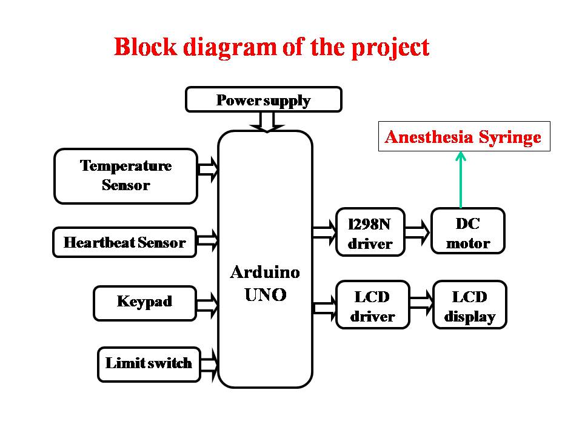

FIG 3.1: Block diagram of Smart Anesthesia Syringe

The main blocks of this project are:
- Power supply.
- Arduino UNO.
- Heartbeat and temperature sensor.
- L298 along with DC Motor.
- LM35 temperature sensor.
- LCD display.
- Keypad.
3.2 Micro controller:
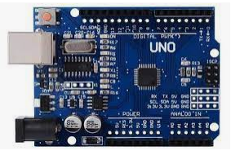
Fig:Arduino UN
The Arduino board exposes most of the microcontroller's I/O pins for use by other circuits. The Diecimila, Duemilanove, and current Uno provide 14 digital I/O pins, six of which can produce pulse-width modulated signals, and six analog inputs, which can also be used as six digital I/O pins. These pins are on the top of the board, via female 0.1-inch (2.54 mm) headers. Several plug-in application shields are also commercially available. The Arduino Nano, and Arduino-compatible Bare Bones Board and Boarduino boards may provide male header pins on the underside of the board that can plug into solderless breadboards.
ATMEGA328:
Features
• High Performance, Low Power AVR® 8-Bit Microcontroller
• Advanced RISC Architecture
– 131 Powerful Instructions – Most Single Clock Cycle Execution
– 32 x 8 General Purpose Working Registers
– Fully Static Operation
– Up to 20 MIPS Throughput at 20 MHz
– On-chip 2-cycle Multiplier
• High Endurance Non-volatile Memory Segments
– 4/8/16/32K Bytes of In-System Self-Programmable Flash progam memory
(ATmega48PA/88PA/168PA/328P)
– 256/512/512/1K Bytes EEPROM (ATmega48PA/88PA/168PA/328P)
– 512/1K/1K/2K Bytes Internal SRAM (ATmega48PA/88PA/168PA/328P)
– Write/Erase Cycles: 10,000 Flash/100,000 EEPROM
– Data retention: 20 years at 85°C/100 years at 25°C(1)
– Optional Boot Code Section with Independent Lock Bits
In-System Programming by On-chip Boot Program
True Read-While-Write Operation
– Programming Lock for Software Security
• Peripheral Features
– Two 8-bit Timer/Counters with Separate Prescaler and Compare Mode
– One 16-bit Timer/Counter with Separate Prescaler, Compare Mode, and Capture
Mode
– Real Time Counter with Separate Oscillator
– Six PWM Channels
– 8-channel 10-bit ADC in TQFP and QFN/MLF package
Temperature Measurement
– 6-channel 10-bit ADC in PDIP Package
Temperature Measurement
– Programmable Serial USART
– Master/Slave SPI Serial Interface
– Byte-oriented 2-wire Serial Interface (Philips I2C compatible)
– Programmable Watchdog Timer with Separate On-chip Oscillator
– On-chip Analog Comparator
– Interrupt and Wake-up on Pin Change
• Special Microcontroller Features
– Power-on Reset and Programmable Brown-out Detection
– Internal Calibrated Oscillator
– External and Internal Interrupt Sources
– Six Sleep Modes: Idle, ADC Noise Reduction, Power-save, Power-down, Standby, and Extended Standby
• I/O and Packages
– 23 Programmable I/O Lines
– 28-pin PDIP, 32-lead TQFP, 28-pad QFN/MLF and 32-pad QFN/MLF
• Operating Voltage:
– 1.8 - 5.5V for ATmega48PA/88PA/168PA/328P
• Temperature Range:
– -40°C to 85°C
• Speed Grade:
– 0 - 20 MHz @ 1.8 - 5.5V
• Low Power Consumption at 1 MHz, 1.8V, 25°C for ATmega48PA/88PA/168PA/328P:
– Active Mode: 0.2 mA
– Power-down Mode: 0.1 μA
- Power-save Mode: 0.75 μA (Including 32 kHz RTC)

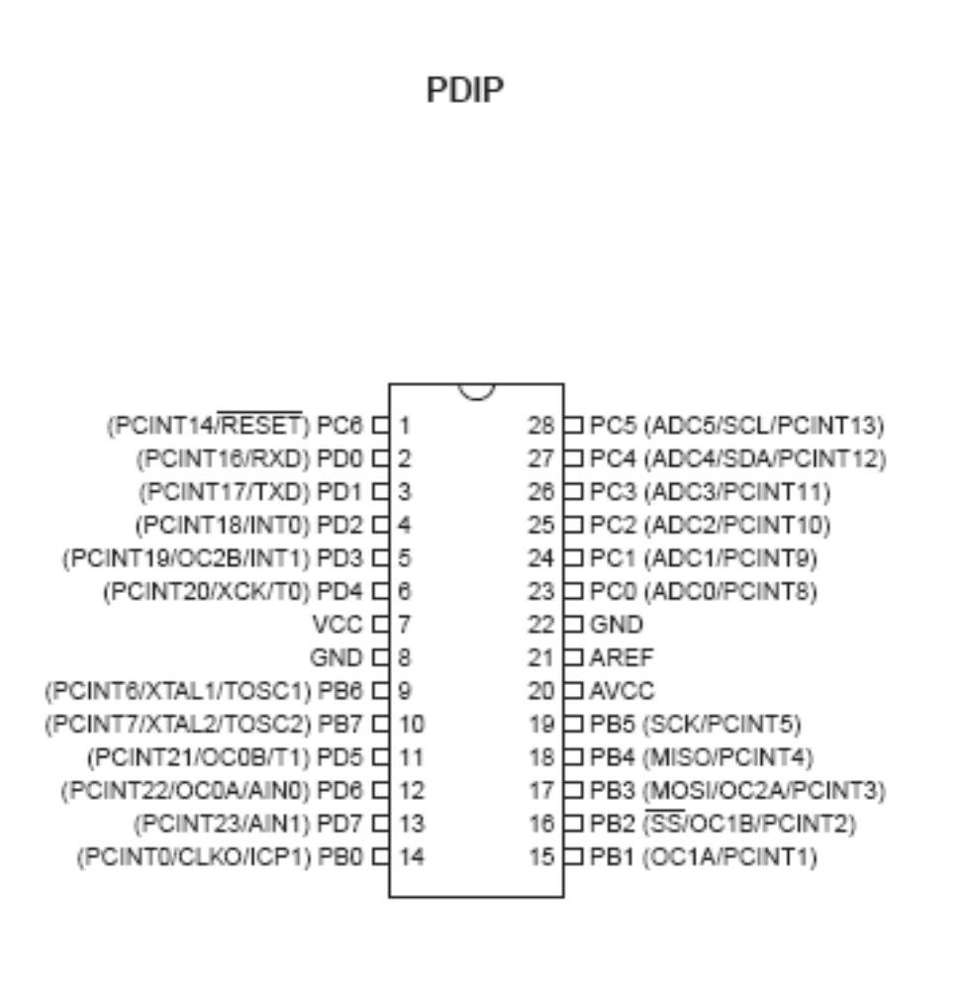
1.1 Pin Descriptions
1.1.1 VCC Digital supply voltage.
1.1.2 GND Ground.
1.1.3 Port B (PB7:0) XTAL1/XTAL2/TOSC1/TOSC2
Port B is an 8-bit bi-directional I/O port with internal pull-up resistors (selected for each it). The Port B output buffers have symmetrical drive characteristics with both high sink and source capability. As inputs, Port B pins that are externally pulled low will source current if the pull-up resistors are activated. The Port B pins are tri-stated when a reset condition becomes active, even if the clock is not running. Depending on the clock selection fuse settings, PB6 can be used as input to the inverting Oscillator amplifier and input to the internal clock operating circuit. Depending on the clock selection fuse settings, PB7 can be used as output from the inverting Oscillator amplifier.
If the Internal Calibrated RC Oscillator is used as chip clock source, PB7..6 is used as TOSC2..1 input for the Asynchronous Timer/Counter2 if the AS2 bit in ASSR is set. The various special features of Port B are elaborated in ”Alternate Functions of Port B” on page 82 and ”System Clock and Clock Options” on page 26.
1.1.4 Port C (PC5:0)
Port C is a 7-bit bi-directional I/O port with internal pull-up resistors (selected for each it). The PC5..0 output buffers have symmetrical drive characteristics with both high sink and source capability. As inputs, Port C pins that are externally pulled low will source current if the pull-up resistors are activated. The Port C pins are tri-stated when a reset condition becomes active, even if the clock is not running.
1.1.5 PC6/RESET
If the RSTDISBL Fuse is programmed, PC6 is used as an I/O pin. Note that the electrical characteristics of PC6 differ from those of the other pins of Port C. If the RSTDISBL Fuse is un programmed, PC6 is used as a Reset input. A low level on this pin for longer than the minimum pulse length will generate a Reset, even if the clock is not running.
The minimum pulse length is given in Table 28-3 on page 318. Shorter pulses are not guaranteed to generate a Reset. The various special features of Port C are elaborated in ”Alternate Functions of Port C” on page 85.
1.1.6 Port D (PD7:0)
Port D is an 8-bit bi-directional I/O port with internal pull-up resistors (selected for each bit). The Port D output buffers have symmetrical drive characteristics with both high sink and source capability. As inputs, Port D pins that are externally pulled low will source current if the pull-up resistors are activated. The Port D pins are tri-stated when a reset condition becomes active, even if the clock is not running. The various special features of Port D are elaborated in ”Alternate Functions of Port D” on page
88. 1.1.7 AVCC
AVCC is the supply voltage pin for the A/D Converter, PC3:0, and ADC7:6. It should be externally connected to VCC, even if the ADC is not used. If the ADC is used, it should be connected to VCC through a low-pass filter. Note that PC6..4 use digital supply voltage, VCC.
1.1.8 AREF
AREF is the analog reference pin for the A/D Converter.
1.1.9 ADC7:6 (TQFP and QFN/MLF Package Only)
In the TQFP and QFN/MLF package, ADC7:6 serve as analog inputs to the A/D converter. These pins are powered from the analog supply and serve as 10-bit ADC channels.
Overview
The ATmega48PA/88PA/168PA/328P is a low-power CMOS 8-bit microcontroller based on the AVR enhanced RISC architecture. By executing powerful instructions in a single clock cycle, the ATmega48PA/88PA/168PA/328P achieves throughputs approaching 1 MIPS per MHz allowing the system designer to optimize power consumption versus processing speed.
2.1 Block Diagram
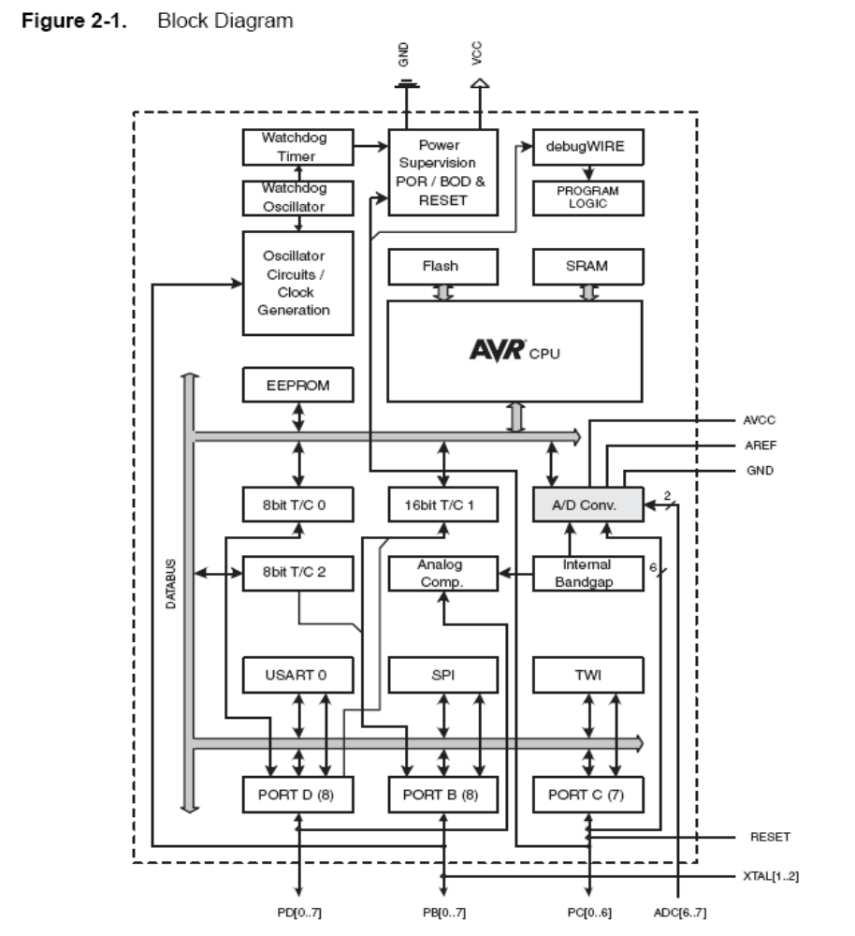
The AVR core combines a rich instruction set with 32 general purpose working registers. All the 32 registers are directly connected to the Arithmetic Logic Unit (ALU), allowing two independent registers to be accessed in one single instruction executed in one clock cycle. The resulting architecture is more code efficient while achieving throughputs up to ten times faster than conventional CISC microcontrollers.
The ATmega48PA/88PA/168PA/328P provides the following features: 4K/8K bytes of In-System Programmable Flash with Read-While-Write capabilities, 256/512/512/1K bytes EEPROM, 512/1K/1K/2K bytes SRAM, 23 general purpose I/O lines, 32 general purpose working registers, three flexible Timer/Counters with compare modes, internal and external interrupts, a serial programmable USART, a byte-oriented 2-wire Serial Interface, an SPI serial port, a 6-channel 10-bit ADC (8 channels in TQFP and QFN/MLF packages), a programmable Watchdog Timer with internal Oscillator, and five software selectable power saving modes. The Idle mode stops the CPU while allowing the SRAM, Timer/Counters, USART, 2-wire Serial Interface, SPI port, and interrupt system to continue functioning. The Power-down mode saves the register contents but freezes the Oscillator, disabling all other chip functions until the next interrupt or hardware reset.
In Power-save mode, the asynchronous timer continues to run, allowing the user to maintain a timer base while the rest of the device is sleeping. The ADC Noise Reduction mode stops the CPU and all I/O modules except asynchronous timer and ADC, to minimize switching noise during ADC conversions. In Standby mode, the crystal/resonator Oscillator is running while the rest of the device is sleeping. This allows very fast start-up combined with low power consumption.
The device is manufactured using Atmel’s high density non-volatile memory technology. The On-chip ISP Flash allows the program memory to be reprogrammed In-System through an SPI serial interface, by a conventional non-volatile memory programmer, or by an On-chip Boot program running on the AVR core. The Boot program can use any interface to download the application program in the Application Flash memory. Software in the Boot Flash section will continue to run while the Application Flash section is updated, providing true Read-While-Write operation. By combining an 8-bit RISC CPU with In-System Self-Programmable Flash on a monolithic chip, the Atmel ATmega48PA/88PA/168PA/328P is a powerful microcontroller that provides a highly flexible and cost effective solution to many embedded control applications.
The ATmega48PA/88PA/168PA/328P AVR is supported with a full suite of program and system development tools including: C Compilers, Macro Assemblers, Program Debugger/Simulators, In-Circuit Emulators, and Evaluation kits.
2.2 Comparison Between ATmega48PA, ATmega88PA, ATmega168PA and ATmega328P

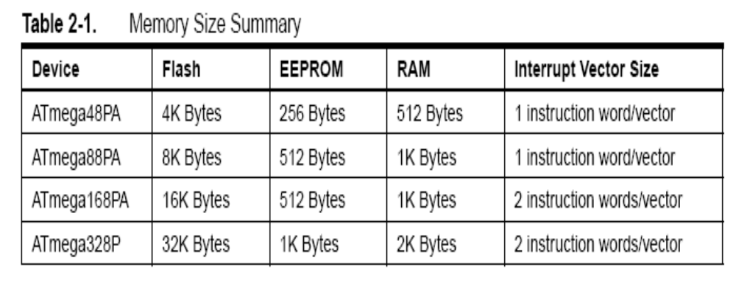
The ATmega48PA, ATmega88PA, ATmega168PA and ATmega328P differ only in memory sizes, boot loader support, and interrupt vector sizes. Table 2-1 summarizes the different memory and interrupts vector sizes for the three devices.
ATmega88PA, ATmega168PA and ATmega328P support a real Read-While-Write Self-Programming mechanism. There is a separate Boot Loader Section, and the SPM instruction can only execute from there. In ATmega48PA, there is no Read-While-Write support and no separate Boot Loader Section. The SPM instruction can execute from the entire Flash.
AVR CPU Core
6.1 Overview
This section discusses the AVR core architecture in general. The main function of the CPU core is to ensure correct program execution. The CPU must therefore be able to access memories, perform calculations, control peripherals, and handle interrupts.
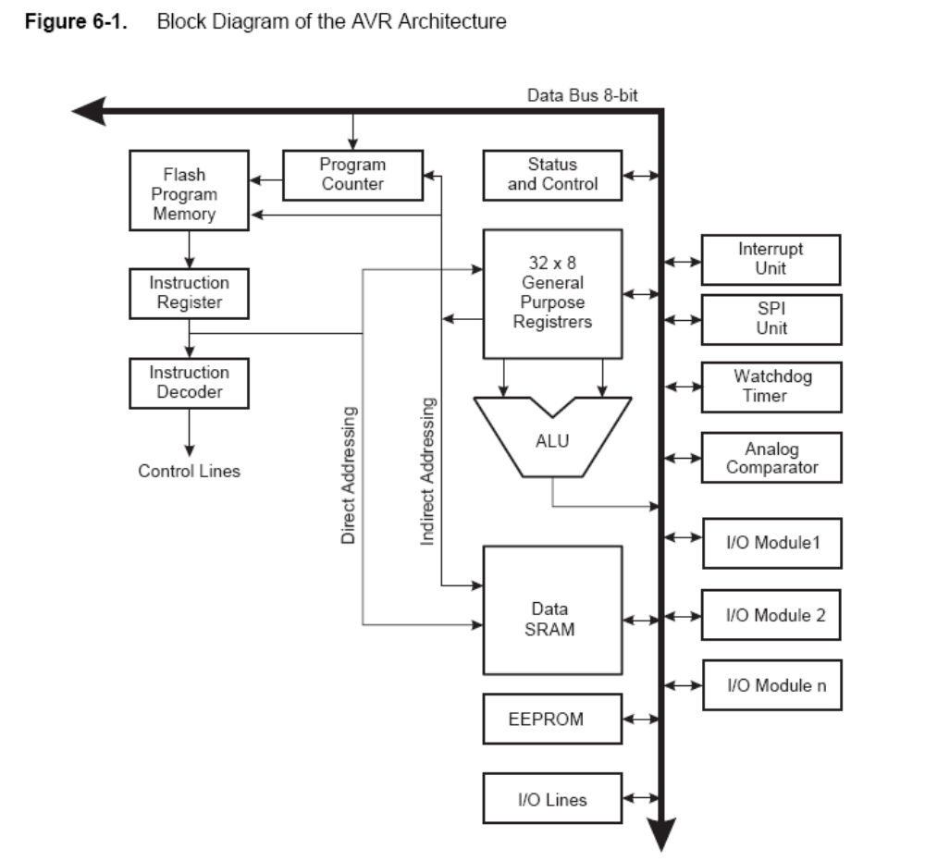

In order to maximize performance and parallelism, the AVR uses a Harvard architecture – with separate memories and buses for program and data. Instructions in the program memory are executed with a single level pipelining. While one instruction is being executed, the next instruction is pre-fetched from the program memory. This concept enables instructions to be executed in every clock cycle. The program memory is In-System Reprogrammable Flash memory.
The fast-access Register File contains 32 x 8-bit general purpose working registers with a single clock cycle access time. This allows single-cycle Arithmetic Logic Unit (ALU) operation. In a typical ALU operation, two operands are output from the Register File, the operation is executed, and the result is stored back in the Register File – in one clock cycle. Six of the 32 registers can be used as three 16-bit indirect address register pointers for Data Space addressing – enabling efficient address calculations. One of the these address pointers can also be used as an address pointer for look up tables in Flash program memory. These added function registers are the 16-bit X-, Y-, and Z-register, described later in this section.
The ALU supports arithmetic and logic operations between registers or between a constant and a register. Single register operations can also be executed in the ALU. After an arithmetic operation, the Status Register is updated to reflect information about the result of the operation.
Program flow is provided by conditional and unconditional jump and call instructions, able to directly address the whole address space. Most AVR instructions have a single 16-bit word format. Every program memory address contains a 16- or 32-bit instruction.
Program Flash memory space is divided in two sections, the Boot Program section and the Application Program section. Both sections have dedicated Lock bits for write and read/write protection. The SPM instruction that writes into the Application Flash memory section must reside in the Boot Program section.
During interrupts and subroutine calls, the return address Program Counter (PC) is stored on the Stack. The Stack is effectively allocated in the general data SRAM, and consequently the Stack size is only limited by the total SRAM size and the usage of the SRAM. All user programs must initialize the SP in the Reset routine (before subroutines or interrupts are executed). The Stack Pointer (SP) is read/write accessible in the I/O space. The data SRAM can easily be accessed through the five different addressing modes supported in the AVR architecture.
The memory spaces in the AVR architecture are all linear and regular memory maps.
A flexible interrupt module has its control registers in the I/O space with an additional Global Interrupt Enable bit in the Status Register. All interrupts have a separate Interrupt Vector in the Interrupt Vector table. The interrupts have priority in accordance with their Interrupt Vector position.
The lower the Interrupt Vector address, the higher the priority.
The I/O memory space contains 64 addresses for CPU peripheral functions as Control Registers,
SPI, and other I/O functions. The I/O Memory can be accessed directly, or as the Data Space locations following those of the Register File, 0x20 - 0x5F. In addition, the ATmega48PA/88PA/168PA/328P has Extended I/O space from 0x60 - 0xFF in SRAM where only the ST/STS/STD and LD/LDS/LDD instructions can be used.
6.2 ALU – Arithmetic Logic Unit
The high-performance AVR ALU operates in direct connection with all the 32 general purpose working registers. Within a single clock cycle, arithmetic operations between general purpose registers or between a register and an immediate are executed. The ALU operations are divided into three main categories – arithmetic, logical, and bit-functions. Some implementations of the architecture also provide a powerful multiplier supporting both signed/unsigned multiplication and fractional format. See the “Instruction Set” section for a detailed description.
6.3 Status Register
The Status Register contains information about the result of the most recently executed arithmetic instruction. This information can be used for altering program flow in order to perform conditional operations. Note that the Status Register is updated after all ALU operations, as specified in the Instruction Set Reference. This will in many cases remove the need for using the dedicated compare instructions, resulting in faster and more compact code. The Status Register is not automatically stored when entering an interrupt routine and restored when returning from an interrupt. This must be handled by software.
AVR Memories
7.1 Overview
This section describes the different memories in the ATmega48PA/88PA/168PA/328P. The AVR architecture has two main memory spaces, the Data Memory and the Program Memory space. In addition, the ATmega48PA/88PA/168PA/328P features an EEPROM Memory for data storage. All three memory spaces are linear and regular.
7.2 In-System Reprogrammable Flash Program Memory
The ATmega48PA/88PA/168PA/328P contains 4/8/16/32K bytes On-chip In-System Reprogrammable Flash memory for program storage. Since all AVR instructions are 16 or 32 bits wide, the Flash is organized as 2/4/8/16K x 16. For software security, the Flash Program memory space is divided into two sections, Boot Loader Section and Application Program Section in ATmega88PA and ATmega168PA. See SELFPRGEN description in section” SPMCSR – Store Program Memory Control and Status Register” on page 292 for more details.
The Flash memory has an endurance of at least 10,000 write/erase cycles. The ATmega48PA/88PA/168PA/328P Program Counter (PC) is 11/12/13/14 bits wide, thus addressing the 2/4/8/16K program memory locations. The operation of Boot Program section and associated Boot Lock bits for software protection are described in detail in ”Self-Programming the Flash, ATmega48PA” on page 269 and ”Boot Loader Support – Read-While-Write Self-Programming, ATmega88PA, ATmega168PA and ATmega328P” on page 277. ”Memory Programming” on page 294 contains a detailed description on Flash Programming in SPI- or Parallel Programming mode.
Constant tables can be allocated within the entire program memory address space (see the LPM – Load Program Memory instruction description).
SRAM Data Memory
The ATmega48PA/88PA/168PA/328P is a complex microcontroller with more peripheral units than can be supported within the 64 locations reserved in the Opcode for the IN and OUT instructions. For the Extended I/O space from 0x60 - 0xFF in SRAM, only the ST/STS/STD and LD/LDS/LDD instructions can be used. The lower 768/1280/1280/2303 data memory locations address both the Register File, the I/O memory, Extended I/O memory, and the internal data SRAM. The first 32 locations address the Register File, the next 64 location the standard I/O memory, then 160 locations of Extended I/O memory, and the next 512/1024/1024/2048 locations address the internal data SRAM.
The five different addressing modes for the data memory cover: Direct, Indirect with Displacement, Indirect, Indirect with Pre-decrement, and Indirect with Post-increment. In the Register File, registers R26 to R31 feature the indirect addressing pointer registers.
The direct addressing reaches the entire data space. The Indirect with Displacement mode reaches 63 address locations from the base address given by the Y- or Z-register.
When using register indirect addressing modes with automatic pre-decrement and post-increment, the address registers X, Y, and Z are decremented or incremented. The 32 general purpose working registers, 64 I/O Registers, 160 Extended I/O Registers, and the 512/1024/1024/2048 bytes of internal data SRAM in the ATmega48PA/88PA/168PA/328P are all accessible through all these addressing modes.
EEPROM Data Memory
The ATmega48PA/88PA/168PA/328P contains 256/512/512/1K bytes of data EEPROM memory. It is organized as a separate data space, in which single bytes can be read and written. The EEPROM has an endurance of at least 100,000 write/erase cycles. The access between the EEPROM and the CPU is described in the following, specifying the EEPROM Address Registers, the EEPROM Data Register, and the EEPROM Control Register.
7.4.1 EEPROM Read/Write Access
The EEPROM Access Registers are accessible in the I/O space.
lets the user software detect when the next byte can be written. If the user code contains instructions that write the EEPROM, some precautions must be taken. In heavily filtered power supplies, VCC is likely to rise or fall slowly on power-up/down. This causes the device for some period of time to run at a voltage lower than specified as minimum for the clock frequency used. In order to prevent unintentional EEPROM writes, a specific write procedure must be followed. Refer to the description of the EEPROM Control Register for details on this. When the EEPROM is read, the CPU is halted for four clock cycles before the next instruction is executed. When the EEPROM is written, the CPU is halted for two clock cycles before the next instruction is executed.
Low Power Crystal Oscillator
Pins XTAL1 and XTAL2 are input and output, respectively, of an inverting amplifier which can be configured for use as an On-chip Oscillator, Either a quartz crystal or a ceramic resonator may be used. This Crystal Oscillator is a low power oscillator, with reduced voltage swing on the XTAL2 output.
It gives the lowest power consumption, but is not capable of driving other clock inputs, and may be more susceptible to noise in noisy environments. C1 and C2 should always be equal for both crystals and resonators. The optimal value of the capacitors depends on the crystal or resonator in use, the amount of stray capacitance, and the electromagnetic noise of the environment. For ceramic resonators, the capacitor values given by the manufacturer should be used.
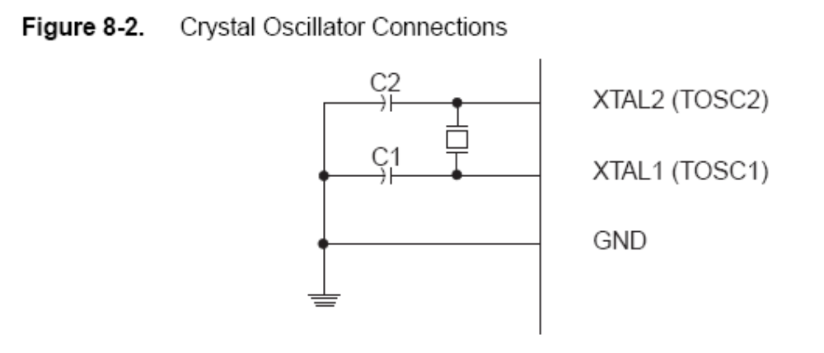
Watchdog Timer
Features
• Clocked from separate On-chip Oscillator
• 3 Operating modes
– Interrupt
– System Reset
– Interrupt and System Reset
• Selectable Time-out period from 16ms to 8s
• Possible Hardware fuse Watchdog always on (WDTON) for fail-safe mode
Overview
ATmega48PA/88PA/168PA/328P has an Enhanced Watchdog Timer (WDT). The WDT is a timer counting cycles of a separate on-chip 128 kHz oscillator. The WDT gives an interrupt or a system reset when the counter reaches a given time-out value. In normal operation mode, it is required that the system uses the WDR - Watchdog Timer Reset - instruction to restart the counter before the time-out value is reached. If the system doesn't restart the counter, an interrupt or system reset will be issued.
In Interrupt mode, the WDT gives an interrupt when the timer expires. This interrupt can be used to wake the device from sleep-modes, and also as a general system timer. One example is to limit the maximum time allowed for certain operations, giving an interrupt when the operation has run longer than expected. In System Reset mode, the WDT gives a reset when the timer expires. This is typically used to prevent system hang-up in case of runaway code. The third mode, Interrupt and System Reset mode, combines the other two modes by first giving an interrupt and then switch to System Reset mode. This mode will for instance allow a safe shutdown by saving critical parameters before a system reset.
The Watchdog always on (WDTON) fuse, if programmed, will force the Watchdog Timer to System Reset mode. With the fuse programmed the System Reset mode bit (WDE) and Interrupt mode bit (WDIE) are locked to 1 and 0 respectively. To further ensure program security, alterations to the Watchdog set-up must follow timed sequences. The sequence for clearing WDE and changing time-out configuration is as follows:
1. In the same operation, write a logic one to the Watchdog change enable bit (WDCE) and WDE. A logic one must be written to WDE regardless of the previous value of the WDE bit.
2. Within the next four clock cycles, write the WDE and Watchdog prescaler bits (WDP) as desired, but with the WDCE bit cleared. This must be done in one operation.
The following code example shows one assembly and one C function for turning off the Watchdog Timer. The example assumes that interrupts are controlled (e.g. by disabling interrupts globally) so that no interrupts will occur during the execution of these functions.
8-bit Timer/Counter0 with PWM
Features
• Two Independent Output Compare Units
• Double Buffered Output Compare Registers
• Clear Timer on Compare Match (Auto Reload)
• Glitch Free, Phase Correct Pulse Width Modulator (PWM)
• Variable PWM Period
• Frequency Generator
• Three Independent Interrupt Sources (TOV0, OCF0A, and OCF0B)
Overview
Timer/Counter0 is a general purpose 8-bit Timer/Counter module, with two independent Output Compare Units, and with PWM support. It allows accurate program execution timing (event management) and wave generation.
CPU accessible I/O Registers, including I/O bits and I/O pins, are shown in bold.
3.3 3.4. Adapter:
The AC adapter, AC/DC adapter or AC/DC converter is a type of external power supply, often enclosed in a case similar to an AC plug. Other names include plug pack, plug-in adapter, adapter block, domestic mains adapter, line power adapter, wall wart, or power adapter. AC adapters are used with electrical devices that require power but do not contain internal components to derive the required voltage and power from mains power. The internal circuitry of an external power supply is very similar to the design that would be used for a built-in or internal supply.
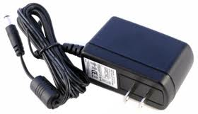
External power supplies are used both with equipment with no other source of power and with battery-powered equipment, where the supply, when plugged in, can sometimes charge the battery in addition to powering the equipment.
Use of an external power supply allows portability of battery-powered equipment without the added bulk of internal power components and makes it unnecessary to produce equipment for use only with a specified power source
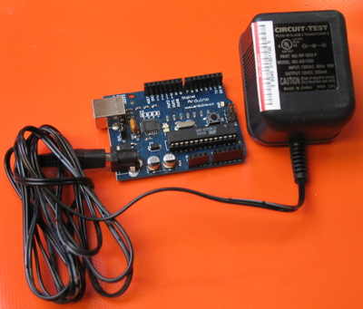
- must be a DC adapter (i.e. it has to put out DC, not AC);
- should be between 9V and 12V DC (see note below);
- must be rated for a minimum of 250mA current output, although you will likely want something more like 500mA or 1A output, as it gives you the current necessary to power a servo or twenty LEDs if you want to.
- must have a 2.1mm power plug on the Arduino end, and
- The plug must be "centre positive", that is, the middle pin of the plug has to be the + connection.

3.4. LED:
A light-emitting diode (LED) is a semiconductor light source. LED’s are used as indicator lamps in many devices, and are increasingly used for lighting. Introduced as a practical electronic component in 1962, early LED’s emitted low-intensity red light, but modern versions are available across the visible, ultraviolet and infrared wavelengths, with very high brightness. The internal structure and parts of a led are shown in figures 3.4.1 and 3.4.2 respectively.
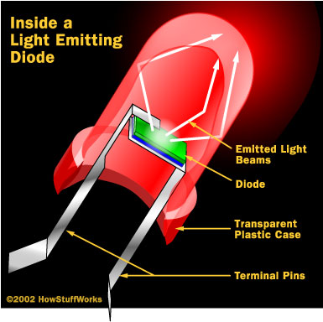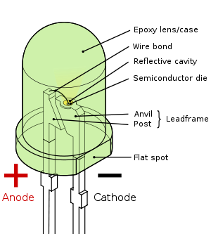
Fig 3.4.1: Inside a LED Fig 3.4.2: Parts of a LED

Working:
The structure of the LED light is completely different than that of the light bulb. Amazingly, the LED has a simple and strong structure. The light-emitting semiconductor material is what determines the LED's color. The LED is based on the semiconductor diode.
When a diode is forward biased (switched on), electrons are able to recombine with holes within the device, releasing energy in the form of photons. This effect is called electroluminescence and the color of the light (corresponding to the energy of the photon) is determined by the energy gap of the semiconductor. An LED is usually small in area (less than 1 mm²), and integrated optical components are used to shape its radiation pattern and assist in reflection. LED’s present many advantages over incandescent light sources including lower energy consumption, longer lifetime, improved robustness, smaller size, faster switching, and greater durability and reliability. However, they are relatively expensive and require more precise current and heat management than traditional light sources. Current LED products for general lighting are more expensive to buy than fluorescent lamp sources of comparable output. They also enjoy use in applications as diverse as replacements for traditional light sources in automotive lighting (particularly indicators) and in traffic signals. The compact size of LED’s has allowed new text and video displays and sensors to be developed, while their high switching rates are useful in advanced communications technology. The electrical symbol and polarities of led are shown in fig: 3.4.3.
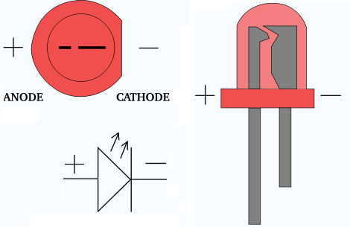
Fig 3.4.3: Electrical Symbol & Polarities of LED
LED lights have a variety of advantages over other light sources:
- High-levels of brightness and intensity
- High-efficiency
- Low-voltage and current requirements
- Low radiated heat
- High reliability (resistant to shock and vibration)
- No UV Rays
- Long source life
- Can be easily controlled and programmed
Applications of LED fall into three major categories:
- Visual signal application where the light goes more or less directly from the LED to the human eye, to convey a message or meaning.
- Illumination where LED light is reflected from object to give visual response of these objects.
- Generate light for measuring and interacting with processes that do not involve the human visual system.

3.5 TEMPERATURE SENSOR:
Introduction:
LM 35: (TEMPERATURE /FIRE SENSOR):
The LM35 sensor series are precision integrated-circuit temperature sensors, whose output voltage is linearly proportional to the Celsius (Centigrade) temperature.
To detect the heat produced during fire occurrence we use temperature sensor.
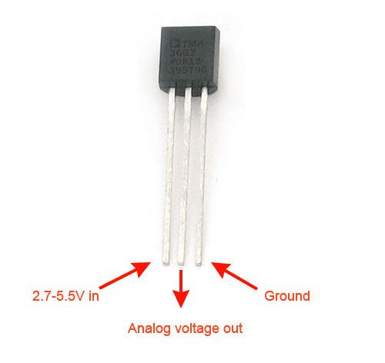
The Temperature Sensor LM35 sensor series are precision integrated-circuit temperature sensors, whose output voltage is linearly proportional to the Celsius (Centigrade) temperature.
Description:
Temperature is the most-measured process variable in industrial automation. Most commonly, a temperature sensor is used to convert temperature value to an electrical value. Temperature Sensors are the key to read temperatures correctly and to control temperature in industrials applications.

A large distinction can be made between temperature sensor types. Sensors differ a lot in properties such as contact-way, temperature range, calibrating method and sensing element. The temperature sensors contain a sensing element enclosed in housings of plastic or metal. With the help of conditioning circuits, the sensor will reflect the change of environmental temperature.

LM35 Sensor Specification:

The LM35 series are precision integrated-circuit LM35 temperature sensors, whose output voltage is linearly proportional to the Celsius (Centigrade) temperature. The LM35 sensor thus has an advantage over linear temperature sensors calibrated in ° Kelvin, as the user is not required to subtract a large constant voltage from its output to obtain convenient Centigrade scaling. The LM35 sensor does not require any external calibration or trimming to provide typical accuracies of ±¼°C at room temperature and ±¾°C over a full -55 to +150°C temperature range. Low cost is assured by trimming and calibration at the wafer level. The LM35's low output impedance, linear output, and precise inherent calibration make interfacing to readout or control circuitry especially easy. It can be used with single power supplies, or with plus and minus supplies. As it draws only 60 µA from its supply, it has very low self-heating, less than 0.1°C in still air. The LM35 is rated to operate over a -55° to +150°C temperature range, while the LM35C sensor is rated for a -40° to +110°C range (-10° with improved accuracy). The LM35 series is available packaged in hermetic TO-46 transistor packages, while the LM35C, LM35CA, and LM35D are also available in the plastic TO-92 transistor package. The LM35D sensor is also available in an 8-lead surface mount small outline package and a plastic TO-220 package.

LM35 Sensor Pin outs and Packaging:

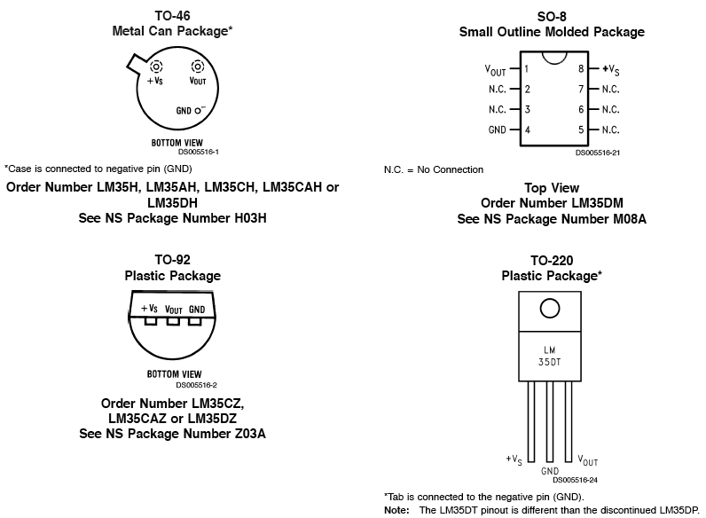
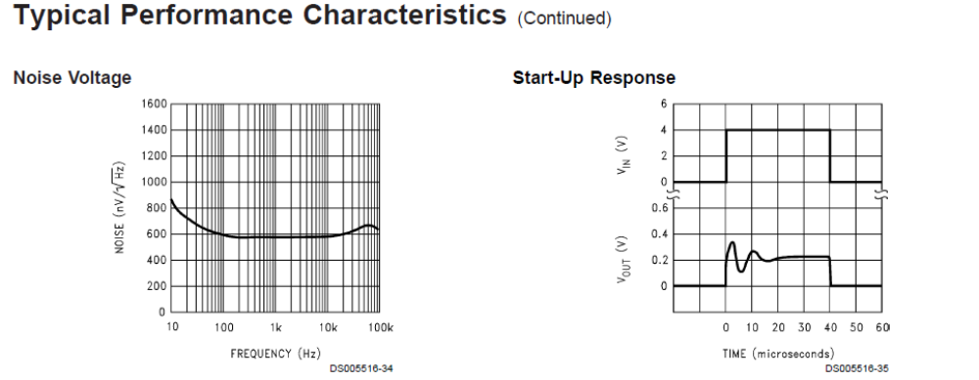
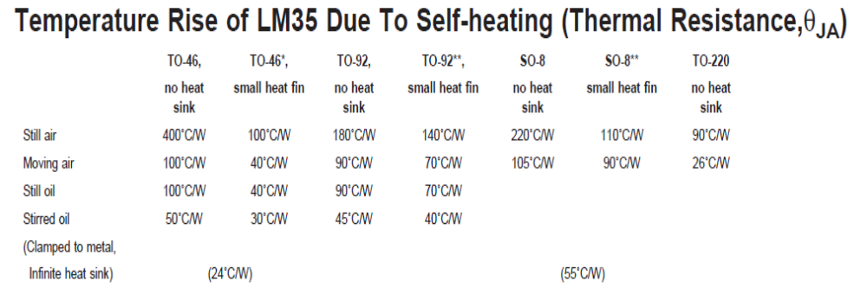
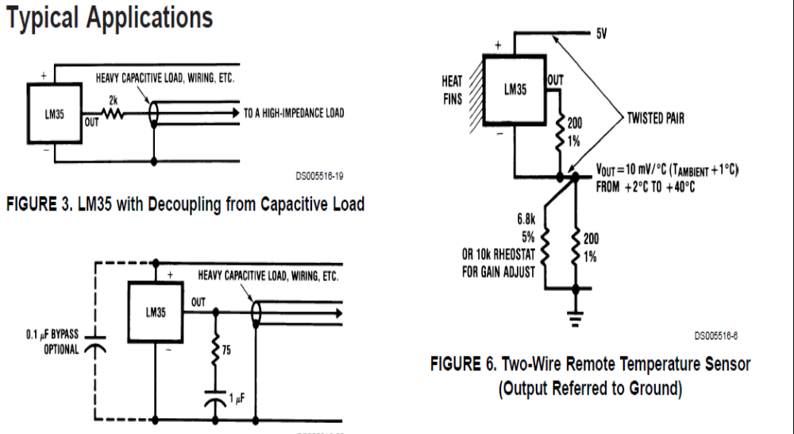

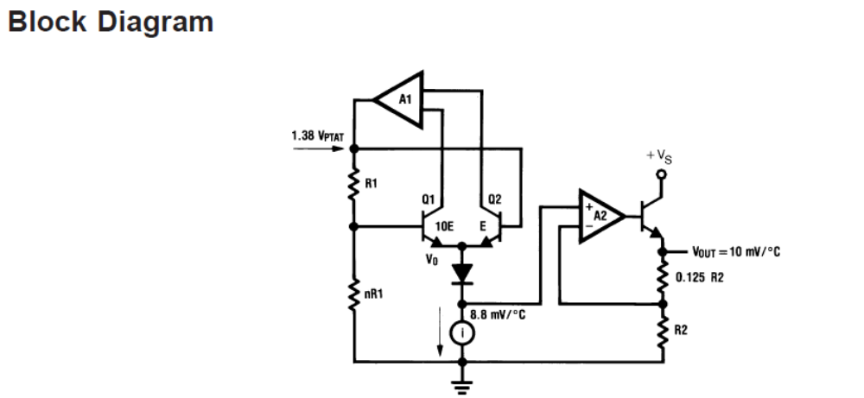

3.6 LCD display:
LCD Background:
One of the most common devices attached to a micro controller is an LCD display. Some of the most common LCD’s connected to the many microcontrollers are 16x2 and 20x2 displays. This means 16 characters per line by 2 lines and 20 characters per line by 2 lines, respectively.
Basic 16x 2 Characters LCD
Figure 1: LCD Pin diagram
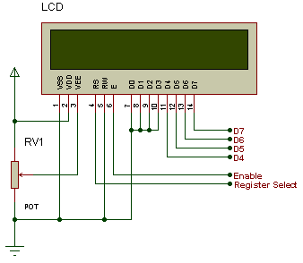
Pin description:
Pin No. | Name | Description
Pin no. 1 | VSS | Power supply (GND)
Pin no. 2 | VCC | Power supply (+5V)
Pin no. 3 | VEE | Contrast adjust
Pin no. 4 | RS | 0 = Instruction input  1 = Data input
Pin no. 5 | R/W | 0 = Write to LCD module  1 = Read from LCD module
Pin no. 6 | EN | Enable signal
Pin no. 7 | D0 | Data bus line 0 (LSB)
Pin no. 8 | D1 | Data bus line 1
Pin no. 9 | D2 | Data bus line 2
Pin no. 10 | D3 | Data bus line 3
Pin no. 11 | D4 | Data bus line 4
Pin no. 12 | D5 | Data bus line 5
Pin no. 13 | D6 | Data bus line 6
Pin no. 14 | D7 | Data bus line 7 (MSB)
Table 1: Character LCD pins with Microcontroller
The LCD requires 3 control lines as well as either 4 or 8 I/O lines for the data bus. The user may select whether the LCD is to operate with a 4-bit data bus or an 8-bit data bus. If a 4-bit data bus is used the LCD will require a total of 7 data lines (3 control lines plus the 4 lines for the data bus). If an 8-bit data bus is used the LCD will require a total of 11 data lines (3 control lines plus the 8 lines for the data bus).
The three control lines are referred to as EN, RS, and RW.
The EN line is called "Enable." This control line is used to tell the LCD that we are sending it data. To send data to the LCD, our program should make sure this line is low (0) and then set the other two control lines and/or put data on the data bus. When the other lines are completely ready, bring EN high (1) and wait for the minimum amount of time required by the LCD datasheet (this varies from LCD to LCD), and end by bringing it low (0) again.

The RS line is the "Register Select" line. When RS is low (0), the data is to be treated as a command or special instruction (such as clear screen, position cursor, etc.). When RS is high (1), the data being sent is text data which should be displayed on the screen. For example, to display the letter "T" on the screen we would set RS high.
The RW line is the "Read/Write" control line. When RW is low (0), the information on the data bus is being written to the LCD. When RW is high (1), the program is effectively querying (or reading) the LCD. Only one instruction ("Get LCD status") is a read command. All others are write commands--so RW will almost always be low.
Finally, the data bus consists of 4 or 8 lines (depending on the mode of operation selected by the user). In the case of an 8-bit data bus, the lines are referred to as DB0, DB1, DB2, DB3, DB4, DB5, DB6, and DB7.
Schematic:
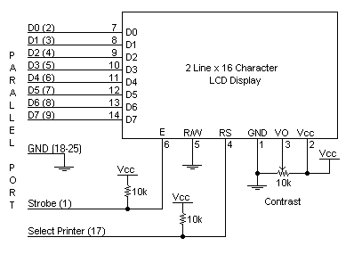
Circuit Description:
Above is the quite simple schematic. The LCD panel's Enable and Register Select is connected to the Control Port. The Control Port is an open collector / open drain output. While most Parallel Ports have internal pull-up resistors, there is a few which don't. Therefore by incorporating the two 10K external pull up resistors, the circuit is more portable for a wider range of computers, some of which may have no internal pull up resistors.
We make no effort to place the Data bus into reverse direction. Therefore we hard wire the R/W line of the LCD panel, into write mode. This will cause no bus conflicts on the data lines. As a result we cannot read back the LCD's internal Busy Flag which tells us if the LCD has accepted and finished processing the last instruction. This problem is overcome by inserting known delays into our program.
The 10k Potentiometer controls the contrast of the LCD panel. Nothing fancy here. As with all the examples, I've left the power supply out. We can use a bench power supply set to 5v or use an onboard +5 regulator. Remember a few de-coupling capacitors, especially if we have trouble with the circuit working properly.
SETB RW
Handling the EN control line:
As we mentioned above, the EN line is used to tell the LCD that we are ready for it to execute an instruction that we've prepared on the data bus and on the other control lines. Note that the EN line must be raised/ lowered before/after each instruction sent to the LCD regardless of whether that instruction is read or write text or instruction. In short, we must always manipulate EN when communicating with the LCD. EN is the LCD's way of knowing that we are talking to it. If we don't raise/lower EN, the LCD doesn't know we're talking to it on the other lines.
Thus, before we interact in any way with the LCD we will always bring the EN line low with the following instruction:
CLR EN
And once we've finished setting up our instruction with the other control lines and data bus lines, we'll always bring this line high:
SETB EN
The line must be left high for the amount of time required by the LCD as specified in its datasheet. This is normally on the order of about 250 nanoseconds, but checks the datasheet. In the case of a typical microcontroller running at 12 MHz, an instruction requires 1.08 microseconds to execute so the EN line can be brought low the very next instruction. However, faster microcontrollers (such as the DS89C420 which executes an instruction in 90 nanoseconds given an 11.0592 MHz crystal) will require a number of NOPs to create a delay while EN is held high. The number of NOPs that must be inserted depends on the microcontroller we are using and the crystal we have selected.
The instruction is executed by the LCD at the moment the EN line is brought low with a final CLR EN instruction.
Checking the busy status of the LCD:
As previously mentioned, it takes a certain amount of time for each instruction to be executed by the LCD. The delay varies depending on the frequency of the crystal attached to the oscillator input of the LCD as well as the instruction which is being executed.
While it is possible to write code that waits for a specific amount of time to allow the LCD to execute instructions, this method of "waiting" is not very flexible. If the crystal frequency is changed, the software will need to be modified. A more robust method of programming is to use the "Get LCD Status" command to determine whether the LCD is still busy executing the last instruction received.
The "Get LCD Status" command will return to us two tidbits of information; the information that is useful to us right now is found in DB7. In summary, when we issue the "Get LCD Status" command the LCD will immediately raise DB7 if it's still busy executing a command or lower DB7 to indicate that the LCD is no longer occupied. Thus our program can query the LCD until DB7 goes low, indicating the LCD is no longer busy. At that point we are free to continue and send the next command.
3.7 Keypad:

A keypad is a set of buttons arranged in a block or "pad" which usually bear digits and other symbols and usually a complete set of alphabetical letters. If it mostly contains numbers then it can also be called a numeric keypad. Keypads are found on many alphanumeric keyboards and on other devices such as calculators, push-button telephones, combination locks, and digital door locks, which require mainly numeric input.
Keypads are also a feature of some combination locks. This type of lock is often used on doors, such as that found at the main entrance to some offices.
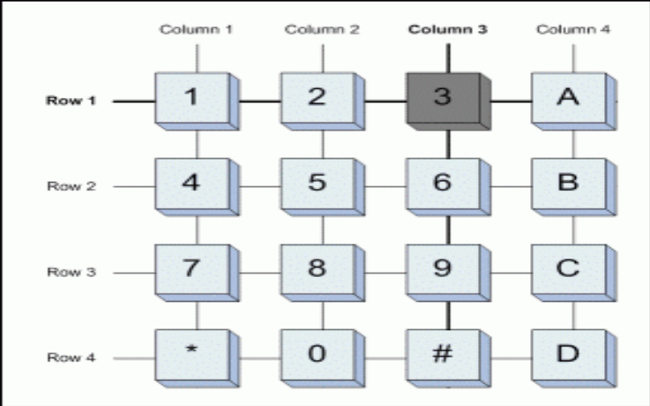

Keypad is an array of switch. There will be 2 wires connected each time a button is pressed. For example; when button ‘1’ is pressed, pin col1 and row1 is connected. There is no connection between rows and also columns. The button makes it connect. To scan which button is pressed, users need to scan it column by column and row by row. Make rows as input and columns as output. For example; set all columns by default. 1st scan, clear (logic low) column 1 and scan row1-row4 low logic, this will determine which button is pressed in column1. If one of those buttons is pressed, record it and jump out from the scanning loop and continue with the action required. If none button is pressed in column1, set it back to default (logic high) and clear column2. Scan row1-row4 again and this will scan button press of ‘2’, ‘5’, ‘8’ and ‘0’. And this process is being repeated until all four columns being completed scanned. For keypad wiring, keypads pins need to pull up or pull down to avoid floating case happen. Pull up normally connect to 5V and pull down is connect to ground.

Working process of Key pad:

Matrix keypads use a combination of four rows and four columns to provide button states to the host device, typically a microcontroller. Underneath each key is a pushbutton, with one end connected to one row, and the other end connected to one column. These connections are shown in Figure
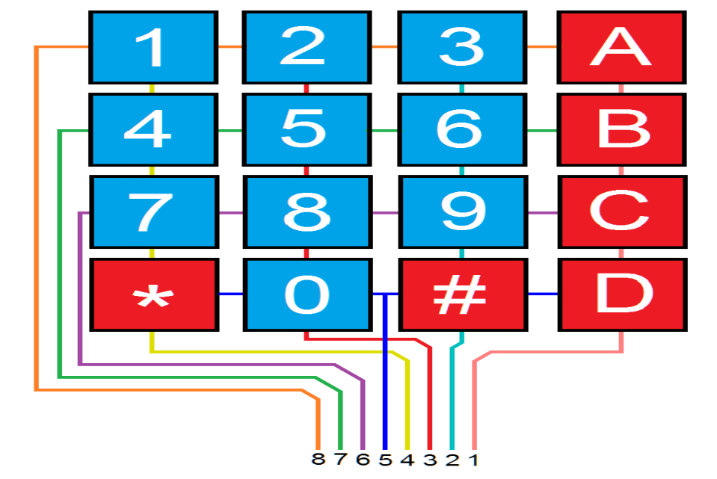

In order for the microcontroller to determine which button is pressed, it first needs to pull each of the four columns (pins 1-4) either low or high one at a time, and then poll the states of the four rows (pins 5-8). Depending on the states of the columns, the microcontroller can tell which button is pressed.

For example, say your program pulls all four columns low and then pulls the first row high. It then reads the input states of each column, and reads pin 1 high. This means that a contact has been made between column 4 and row 1, so button ‘A’ has been pressed.

3.8 Pulse sensor:
Pulse Sensor:
Introduction: Pulse Sensor is a well-designed plug-and-play heart-rate sensor. It can be used by students, artists, athletes, makers, and game & mobile developers who want to easily incorporate live heartrate data into their projects. It also includes an open-source monitoring app that graphs your pulse in real time.
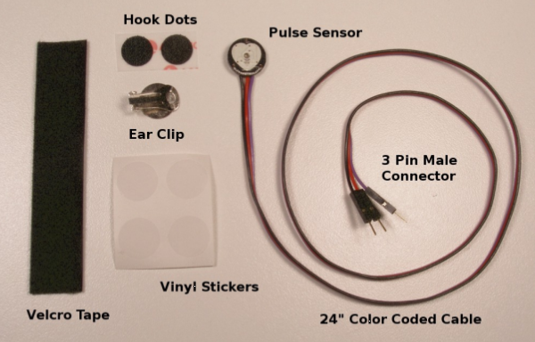

The Pulse Sensor Kit includes:
1) A 24-inch Color-Coded Cable, with (male) header connectors. You'll find this makes it easy to embed the sensor into your project, and connect to an Arduino. No soldering is required.
2) An Ear Clip, perfectly sized to the sensor. We searched many places to find just the right clip. It can be hotglued to the back of the sensor and easily worn on the earlobe.
3) 2 Velcro Dots. These are 'hook' side and are also perfectly sized to the sensor. You'll find these velcro dots very useful if you want to make a velcro (or fabric) strap to wrap around a finger tip. 4) Velcro strap to wrap the Pulse Sensor around your finger.
4) 3 Transparent Stickers. These are used on the front of the Pulse Sensor to protect it from oily fingers and sweaty earlobes.
5) The Pulse Sensor has 3 holes around the outside edge which make it easy to sew it into almost anything.
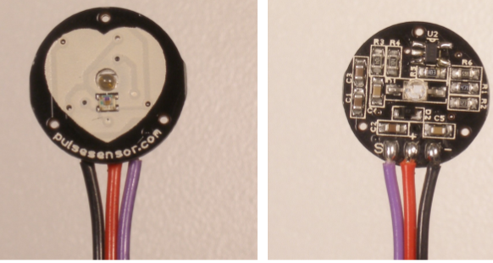

Let’s get started with Pulse Sensor Anatomy The front of the sensor is the pretty side with the Heart logo. This is the side that makes contact with the skin. On the front you see a small round hole, which is where the LED shines through from the back, and there is also a little square just under the LED. The square is an ambient light sensor, exactly like the one used in cellphones, tablets, and laptops, to adjust the screen brightness in different light conditions. The LED shines light into the fingertip or earlobe, or other capillary tissue, and sensor reads the light that bounces back. The back of the sensor is where the rest of the parts are mounted. We put them there so they would not get in the way of the of the sensor on the front. Even the LED we are using is a reverse mount LED. For more about the circuit functionality, check out the Hardware page.[needs link] The cable is a 24” flat color coded ribbon cable with 3 male header connectors.
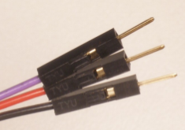
RED wire = +3V to +5V
BLACK wire = GND
PURPLE wire = Signal

3.9 DC motor with L298:
DC. Motor:
A dc motor uses electrical energy to produce mechanical energy, very typically through the interaction of magnetic fields and current-carrying conductors. The reverse process, producing electrical energy from mechanical energy, is accomplished by an alternator, generator or dynamo. Many types of electric motors can be run as generators, and vice versa. The input of a DC motor is current/voltage and its output is torque (speed).

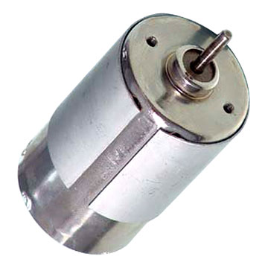
Fig 3.19: DC Motor
The DC motor has two basic parts: the rotating part that is called the armature and the stationary part that includes coils of wire called the field coils. The stationary part is also called the stator. Figure shows a picture of a typical DC motor, Figure shows a picture of a DC armature, and Fig shows a picture of a typical stator. From the picture you can see the armature is made of coils of wire wrapped around the core, and the core has an extended shaft that rotates on bearings. You should also notice that the ends of each coil of wire on the armature are terminated at one end of the armature. The termination points are called the commutator, and this is where the brushes make electrical contact to bring electrical current from the stationary part to the rotating part of the machine.
Operation:
The DC motor you will find in modem industrial applications operates very similarly to the simple DC motor described earlier in this chapter. Figure 12-9 shows an electrical diagram of a simple DC motor. Notice that the DC voltage is applied directly to the field winding and the brushes. The armature and the field are both shown as a coil of wire. In later diagrams, a field resistor will be added in series with the field to control the motor speed. When voltage is applied to the motor, current begins to flow through the field coil from the negative terminal to the positive terminal. This sets up a strong magnetic field in the field winding. Current also begins to flow through the brushes into a commutator segment and then through an armature coil. The current continues to flow through the coil back to the brush that is attached to other end of the coil and returns to the DC power source. The current flowing in the armature coil sets up a strong magnetic field in the armature.
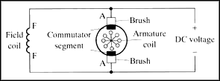
Fig 3.20: Simple electrical diagram of DC motor
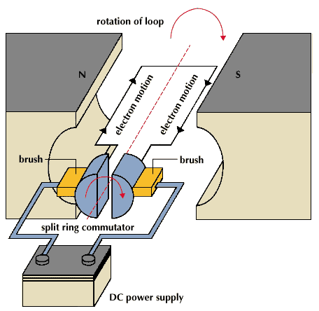
Fig 3.21: Operation of a DC Motor
The magnetic field in the armature and field coil causes the armature to begin to rotate. This occurs by the unlike magnetic poles attracting each other and the like magnetic poles repelling each other. As the armature begins to rotate, the commutator segments will also begin to move under the brushes. As an individual commutator segment moves under the brush connected to positive voltage, it will become positive, and when it moves under a brush connected to negative voltage it will become negative. In this way, the commutator segments continually change polarity from positive to negative. Since the commutator segments are connected to the ends of the wires that make up the field winding in the armature, it causes the magnetic field in the armature to change polarity continually from North Pole to South Pole. The commutator segments and brushes are aligned in such a way that the switch in polarity of the armature coincides with the location of the armature's magnetic field and the field winding's magnetic field. The switching action is timed so that the armature will not lock up magnetically with the field. Instead the magnetic fields tend to build on each other and provide additional torque to keep the motor shaft rotating.
When the voltage is de-energized to the motor, the magnetic fields in the armature and the field winding will quickly diminish and the armature shaft's speed will begin to drop to zero. If voltage is applied to the motor again, the magnetic fields will strengthen and the armature will begin to rotate again.

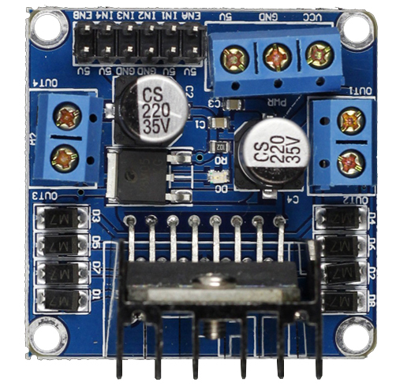

The L298N is an integrated monolithic circuit in a 15- lead Multiwatt and PowerSO20 packages. It is a high voltage, high current dual full-bridge driver de-signed to accept standard TTL logic level sand drive inductive loads such as relays, solenoids, DC and stepping motors. Two enable inputs are provided to enable or disable the device independently of the in-put signals .The emitters of the lower transistors of each bridge are connected together rand the corresponding external terminal can be used for the connection of an external sensing resistor. An additional Supply input is provided so that the logic works at a lower voltage.
Its schematic diagram is as shown in figure (a):

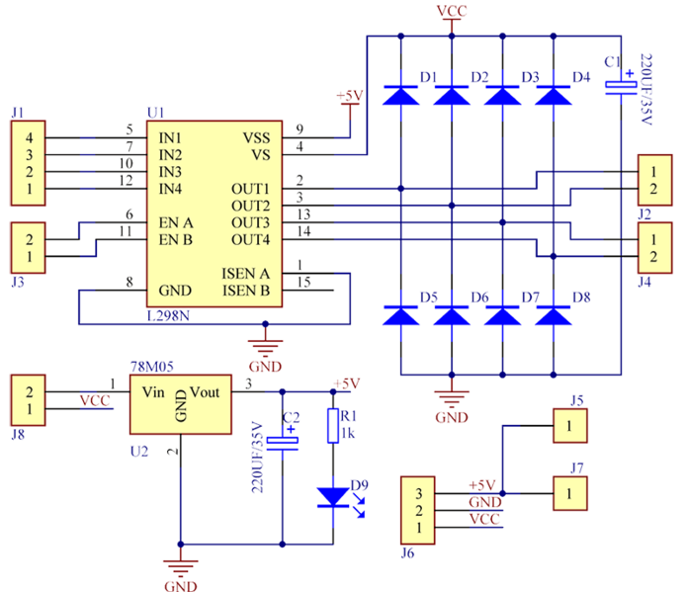

Features:
1) High operating voltage, which can be up to 40 volts;
2) Large output current, the instantaneous peak current can be up to 3A;
3) With 25W rated power;
4) Two built in H-bridge, high voltage, large current, full bridge driver, which can be used to drive DC motors, stepper motors, relay coils and other inductive loads.
5) Using standard logic level signal to control.
6) Able to drive a two-phase stepper motor or four-phase stepper motor, and two-phase DC motors.
7) Adopt a high-capacity filter capacitor and a freewheeling diode that protects devices in the circuit from being damaged by the reverse current of an inductive load, enhancing reliability
8) The module can utilize the built-in stabilivolt tube 78M05 to obtain 5v from the power supply. But to protect the chip of the 78M05 from damage, when the drive voltage is greater than 12v, an external 5v logic supply should be used.
9) Drive voltage: 5-35V; logic voltage: 5V
10) PCB size: 4.2 x 4.2 cm

Pin out:

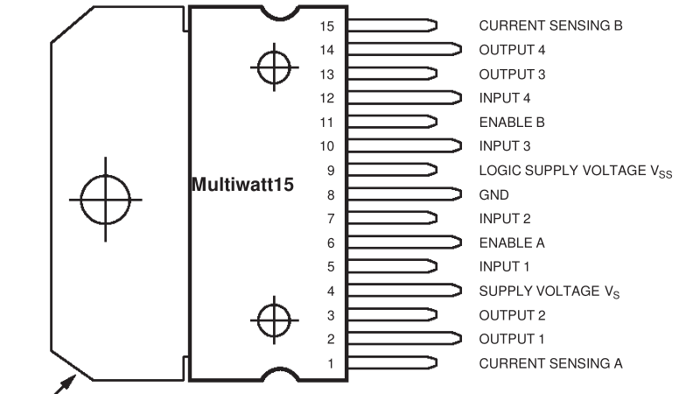

Principle:

The driver module can drive two motors. The enabled terminals ENA and ENB are effective at high level. The control mode and state of motor A are as shown in table (2):
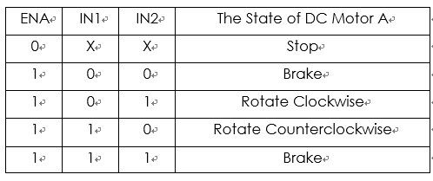
(2) Table for control mode and state of motor A
If you want to regulate the speed of motor A by PWM, you need to set IN1 and IN2, confirm the rotational direction of the motor, and then output PWM pulses for enabled terminals. Please note the motor is in the free stop state when the signal of enabled terminal is 0. When the enabled signal is 1, if IN1 and IN2 are 00 or 11, the motor is in brake state, and the motor stops rotating. If IN1 is 0 and IN2 is 1, the motor A rotates clockwise; if IN1 is 1 and IN2 is 0, the motor A rotates counterclockwise. This is the control method for motor A. The control method for motor B is the same as that for motor A.

Block diagram:
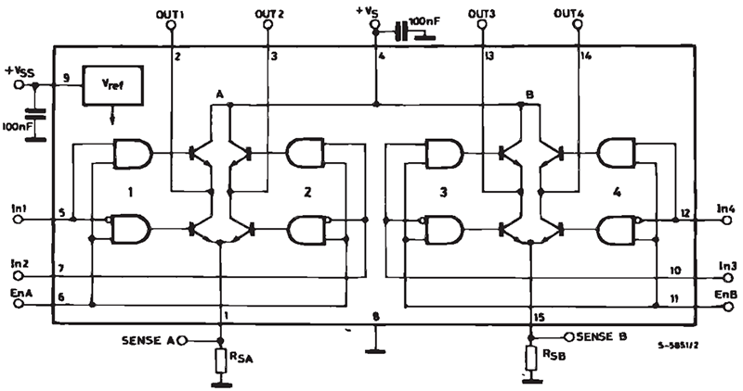

Applications:
- The module can be applied to:
- Drive DC motors. Since the module uses a dual H-bridge drive, it can drive two motors at the same time.
Drive stepping motors. It can also drive two stepping motors synchronously.

3.10 Limit Switch:
A limit switch is an electromechanical device operated by a physical force applied to it by an object. Limit switches are used to detect the presence or absence of an object. These switches were originally used to define the limit of travel of an object, and as a result, they were named Limit Switch.
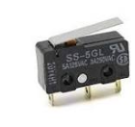
Fig: Limit switch
CHAPTER 4: SOFTWARE DESCRIPTION

This project is implemented using following software’s:
- Express PCB – for designing circuit
- Arduino IDE Studio Compiler - for compilation part
4.1 Express PCB:
Breadboards are great for prototyping equipment as it allows great flexibility to modify a design when needed; however the final product of a project, ideally should have a neat PCB, few cables, and survive a shake test. Not only is a proper PCB neater but it is also more durable as there are no cables which can yank loose.
Express PCB is a software tool to design PCBs specifically for manufacture by the company Express PCB (no other PCB maker accepts Express PCB files). It is very easy to use, but it does have several limitations.
It can be likened to more of a toy then a professional CAD program.
It has a poor part library (which we can work around)
It cannot import or export files in different formats
It cannot be used to make prepare boards for DIY production
Express PCB has been used to design many PCBs (some layered and with surface-mount parts. Print out PCB patterns and use the toner transfer method with an Etch Resistant Pen to make boards. However, Express PCB does not have a nice print layout. Here is the procedure to design in Express PCB and clean up the patterns so they print nicely.
4.1.1 Preparing Express PCB for First Use:
Express PCB comes with a less then exciting list of parts. So before any project is started head over to Audio logic and grab the additional parts by morsel, ppl, and tangent, and extract them into your Express PCB directory. At this point start the program and get ready to setup the workspace to suit your style.
Click View -> Options. In this menu, setup the units for “mm” or “in” depending on how you think, and click “see through the top copper layer” at the bottom. The standard color scheme of red and green is generally used but it is not as pleasing as red and blue.
4.1.2 The Interface:
When a project is first started you will be greeted with a yellow outline. This yellow outline is the dimension of the PCB. Typically after positioning of parts and traces, move them to their final position and then crop the PCB to the correct size. However, in designing a board with a certain size constraint, crop the PCB to the correct size before starting.
Fig: 4.1 show the toolbar in which the each button has the following functions:
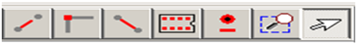
Fig 4.1: Tool bar necessary for the interface
- The select tool: It is fairly obvious what this does. It allows you to move and manipulate parts. When this tool is selected the top toolbar will show buttons to move traces to the top / bottom copper layer, and rotate buttons.
- The zoom to selection tool: does just that.
- The place pad: button allows you to place small soldier pads which are useful for board connections or if a part is not in the part library but the part dimensions are available. When this tool is selected the top toolbar will give you a large selection of round holes, square holes and surface mount pads.
- The place component: tool allows you to select a component from the top toolbar and then by clicking in the workspace places that component in the orientation chosen using the buttons next to the component list. The components can always be rotated afterwards with the select tool if the orientation is wrong.
- The place trace: tool allows you to place a solid trace on the board of varying thicknesses. The top toolbar allows you to select the top or bottom layer to place the trace on.
- The Insert Corner in trace: button does exactly what it says. When this tool is selected, clicking on a trace will insert a corner which can be moved to route around components and other traces.
- The remove a trace button is not very important since the delete key will achieve the same result.
4.1.3 Design Considerations:
Before starting a project there are several ways to design a PCB and one must be chosen to suit the project’s needs.
Single sided, or double sided?
When making a PCB you have the option of making a single sided board, or a double sided board. Single sided boards are cheaper to produce and easier to etch, but much harder to design for large projects. If a lot of parts are being used in a small space it may be difficult to make a single sided board without jumpering over traces with a cable. While there’s technically nothing wrong with this, it should be avoided if the signal travelling over the traces is sensitive (e.g. audio signals).
A double sided board is more expensive to produce professionally, more difficult to etch on a DIY board, but makes the layout of components a lot smaller and easier. It should be noted that if a trace is running on the top layer, check with the components to make sure you can get to its pins with a soldering iron. Large capacitors, relays, and similar parts which don’t have axial leads can NOT have traces on top unless boards are plated professionally.
Ground-plane or other special purposes for one side?
When using a double sided board you must consider which traces should be on what side of the board. Generally, put power traces on the top of the board, jumping only to the bottom if a part cannot be soldiered onto the top plane (like a relay), and vice- versa.
Some projects like power supplies or amps can benefit from having a solid plane to use for ground. In power supplies this can reduce noise, and in amps it minimizes the distance between parts and their ground connections, and keeps the ground signal as simple as possible. However, care must be taken with stubborn chips such as the TPA6120 amplifier from TI. The TPA6120 datasheet specifies not to run a ground plane under the pins or signal traces of this chip as the capacitance generated could effect performance negatively.
4.2 4.2 Arduino IDE Compiler:
This instructable adds to any of the Arduino on a Breadboard instructables.
1. We need a microcontroller with a pre-loaded Bootloader, or must load your own
2. Not all ATmega328’s are equal
(A bootloader, very simply, is a programme that sits on the chip and manages the upload of your sketches onto the chip)
4.3 Procedural steps for compilation, simulation and dumping:
4.3.1 Compilation and simulation steps:
Step 1: Parts
1 x Arduino on a Breadboard
1 x Arduino UNO
Connecting Wires
Arduino IDE installed on your PC

Step 2: The Approach
We use the Arduino UNO to bootload the ATmega328 that is sitting on the Arduino-on-a-Breadboard. This is fairly straightforward having an ATmega328P-PU, but needs an extra step for an ATmega328-PU.
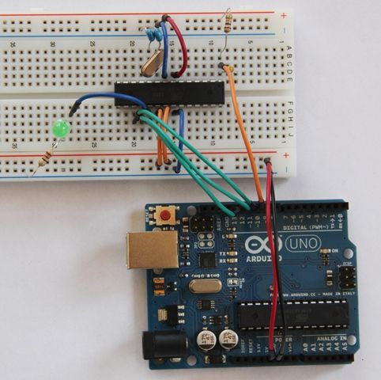
Step 3: Program your Arduino UNO as an ISP

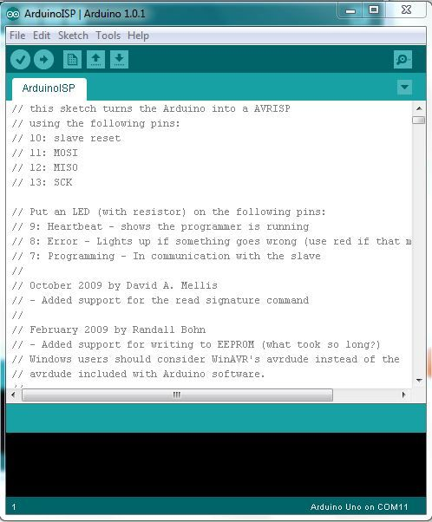
We need to program the Arduino UNO to act as an ISP (In-System Programmer), so that it can burn the bootloader onto the Breadboard chip.
- Open the Arduino IDE
- Open the ArduinoISP sketch (under File, Examples)
- If you’re using version 1.0 of the IDE:
Search for void heartbeat and change the line that reads:
delay(40);
to
delay(20);
Connect your UNO to the PC, making sure it’s not connected to the Arduino on a Breadboard.
Ensure your UNO is selected under the Boards menu option, and upload the sketch.

Step 4: Connect your ATmega328

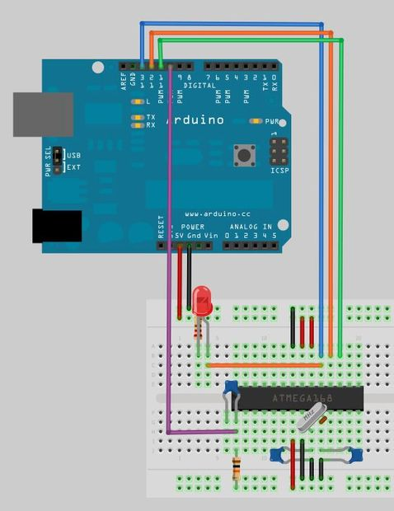

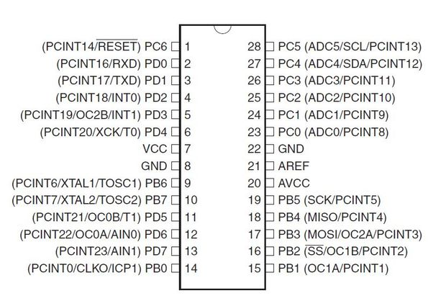
Now connect your ATmega to your UNO as follows:
- UNO 5v ---> ATmega pin 7 (VCC)
- UNO GND ---> ATmega pin 8 (GND)
- UNO pin 10 ---> ATmega pin 1 (RESET)
- UNO pin 11 ---> ATmega pin 17 (MOSI)
- UNO pin 12 ---> ATmega pin 18 (MISO)
- UNO pin 13 ---> ATmega pin 19 (SCK)

Step 5: Which ATmega328 are you using?
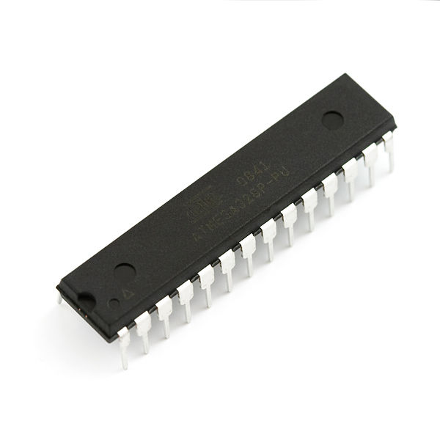

I learnt the hard way that there is more than one type of ATmega328. The two variants that are of interest to us are the ATmega328-PU and the ATmega328P-PU.
The -PU suffix means that the chips are in a PDIP package, the format we need for our breadboard.
The 328P is a picoPower processor, designed for low power consumption, and is used on the Arduino boards. Given low power consumption this is first choice.
The 328 does not have picoPower technology, and is not used on the Arduino boards – and is not explicitly supported by the Arduino IDE.
What this means is that we can easily bootload the ATmega328P, but not the ATmega328. Unfortunately the websites that sell these chips don't always differentiate between them and forums are filled with people struggling to use the ATmega328-PU.
Luckily there is a workaround - take a look at my Crash Bang website.

Step 6: ATmega328-PU workaround

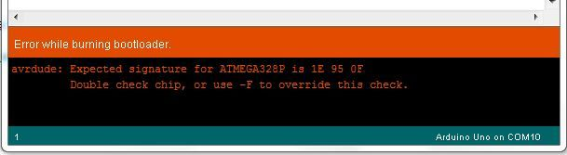
Each microprocessor has a signature – a unique code that identifies its model. When you bootload a chip (or even upload a sketch) the Arduino IDE checks that the chip selected matches the type it’s connected to. Even though the ATmega328-PU in essence functions in the same way as the ATmega328P-PU, it has a different signature, and one that isn’t recognised by the Arduino IDE.
In your Arduino folder, find the subfolder.\hardware\tools\avr\etc
- Make a backup copy of the file: avrdude.conf
- Open the file avrdude.conf in a text editor
- Search for: “0x1e 0x95 0x0F” (this is the ATmega328P signature)
- Replace it with: “0x1e 0x95 0x14” (this is the ATmega328 signature)
- Save the file
- Restart the Arduino IDE
- Continue with the rest of the steps in the instructable, and once bootloading is complete restore the backup copy you made.

Step 7: Bootload the ATmega328
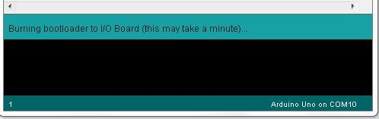
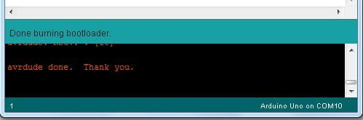
In the Arduino IDE, from the Tools menu:
- under the Board option choose Arduino UNO
- under the Serial Port option ensure the correct port is selected
- under the Programmer option choose Arduino as ISP
To burn the Bootloader, choose Burn Bootloader from the Tools menu
You should see a message “Burning bootloader to I/O Board (this may take a minute)"
Once the bootloader has been burned, a message of confirming the success gets displayed.
”Congratulations: You're now ready to load sketches onto your Arduino on a breadboard!”

CHAPTER 5: PROJECT DESCRIPTION
In this chapter, schematic diagram and interfacing of Arduino UNO microcontroller with each module is considered.
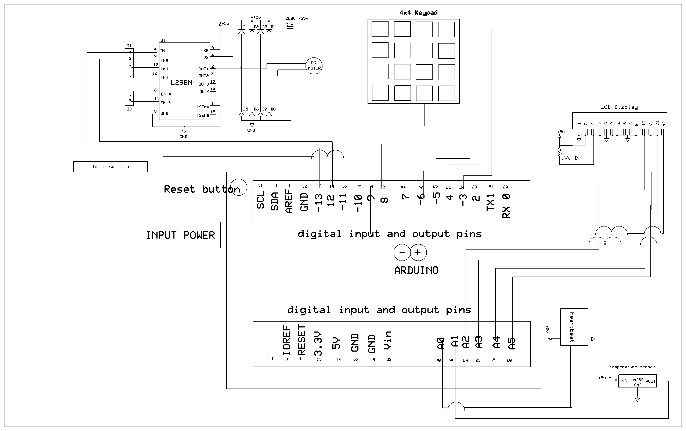

Fig 5.1: schematic diagram of Smart Anesthesia Syringe

The above schematic diagram Smart Anesthesia Syringe explains the interfacing section of each component with micro controller and sensors.

CHAPTER 6: ADVANTAGES AND DISADVANTAGES

Advantages:
- Real time monitoring of health status of a person.
- Patient health parameters monitoring using temperature, pulse sensors.
- Design a Smart Anesthesia Syringe.
- Keypad based an Anesthesia level input.
- Efficient and low cost design.
- Lower power consumption.
- Fast response.

Disadvantages:
- Proper installation required for proper operation of heart beat sensor.
Applications:
This system can be practically implemented in hospitals.

CHAPTER 7: RESULTS

7.1 Result:

- The main controlling device of the project is arduino UNO microcontroller. Temperature sensor, heartbeat sensor, keypad, limit switch and anesthesia syringe along with DC motor is interfaced to the microcontroller.
- Microcontroller will continuously read the data from temperature and heartbeat sensors will be display on LCD module.
- When the user enters the level of anesthesia using keypad, it will read by the microcontroller and microcontroller will inject Syringe pumps which can accurately move a platform attached to the plunger of a syringe with the help of DC motor. Syringe is connected with DC motor along with l298 motor driver and thread screw mechanism. Based on the anesthesia level microcontroller will control the syringe through DC motor. The main controlling device of the project is Arduino UNO, to achieve this task microcontroller loaded program written in embedded C language.
7.2 Conclusion:
Integrating features of all the hardware components used have been developed in it. Presence of every module has been reasoned out and placed carefully, thus contributing to the best working of the unit. Secondly, using highly advanced IC’s with the help of growing technology, the project has been successfully implemented. Thus the project has been successfully designed and tested.
7.3 Future Scope:
- We can extend this project by adding fall detection system to this project.
- We can extend this project by adding more health parameters like glucose meter and BP sensors.

REFERENCES:
[1]. Mihaela Ghita, “Closed-Loop Control of Anesthesia: Survey on actual Trends, challenges and perspectives''. DOI:10.1109/ACCESS.2020.3037725
[2]. Pierre Humbert, “Apprenticeship learning for a predictive state representation of anesthesia” DOI 10.1109/TBME.2019.2954348
[3]. Xinbai Li, “Automatic positioning and recognition of anesthesia points based on ultrasound image guidance technology”,(2020) DOI:10.1109/ACCESS.2020.3003416
[4]. Fali Li, “Identification of general anesthesia induced loss of consciousness by cross fuzzy entropy-based brain network”, (2021) IEEE transactions on neural systems and rehabilitation engineering'' VOL. 29, 2021
[5]. Kyle Wilcocks, Bill Kapralos, “The Anesthesia Crisis Scenario Builder for Authoring Anesthesia Crisis-Based Simulations” (2021) DOI 10.1109/JBHI.2017.2709841, IEEE Journal of Biomedical and Health Informatics

APPENDIX

Program Code:
The program code which is dumped in the microcontroller of our project is shown below.

#include <string.h>
#include <ctype.h>
#include <LiquidCrystal.h>

#include <Keypad.h>
#include <LiquidCrystal.h>

LiquidCrystal lcd(10, 9, 16,17,18,19);

char num[6];

const byte ROWS = 4; //four rows
const byte COLS = 3; //four columns

char keys[ROWS][COLS] = {
{'1','2','3'},
{'4','5','6'},
{'7','8','9'},
{'*','0','#'}
};
byte rowPins[ROWS] = {2,3,4,5}; //connect to the row pinouts of the keypad
byte colPins[COLS] = {6,7,8}; //connect to the column pinouts of the keypad

//Create an object of keypad
Keypad customKeypad = Keypad( makeKeymap(keys), rowPins, colPins, ROWS, COLS );

char *pswd = "4321";
char mypswd[7];

int count = 0;
int hbeat = 0
int i = 0;
int hb = 0;
int h = 0;
int inByte = 0;
int flag = 0;

int ma1 = 12;
int ma2 = 13;
int sw1 = 11;

void back()
{

while( digitalRead(sw1) == 1)
{
digitalWrite(ma1, HIGH); // turn the LED on (HIGH is the voltage level)
digitalWrite(ma2, LOW); // turn the LED off by making the voltage LOW
delay(30);
}
digitalWrite(ma1, LOW); // turn the LED on (HIGH is the voltage level)
digitalWrite(ma2, LOW); // turn the LED off by making the voltage LOW

}

void setup()
{

pinMode(ma1,OUTPUT);
pinMode(ma2,OUTPUT);
pinMode(sw1,INPUT);

lcd.begin(16, 2);
lcd.print("Heart Beat and");
lcd.setCursor(0, 1);
lcd.print("Temperature monit");
delay(2500);
back();

}

void loop()
{
int c;
float f = 0;
count = 0;
int j = 0;
lcd.clear();
lcd.setCursor(0, 0);
lcd.print("Enter Levels:"); //Print blanks to clear the row

while(1)
{
char customKey = customKeypad.getKey();

if (customKey)
{
mypswd[j] = customKey;

lcd.setCursor(j, 1);
lcd.print(customKey); //Print blanks to clear the row

j++;
}
if(j > 2)
{
j = 0;
break;
}
}
int level = atoi(mypswd);
while(1)
{

count = 0;
int h = 0;

h = analogRead(A1);

int a = analogRead(A0);

float temp = (float(a)/1024) * 5; //formulae to convert the ADC value to voltage;
temp = temp*100;

temp = temp * 1.8;
temp = temp+22;

{
lcd.clear();
lcd.setCursor(0, 0);
lcd.print("BPM: "); //Print blanks to clear the row
lcd.print(hbeat); //Print blanks to clear the row
lcd.print(" "); //Print blanks to clear the row
lcd.print(level); //Print blanks to clear the row

lcd.setCursor(0, 1);
lcd.print("B-Temp-DegF:"); //Print blanks to clear the row
lcd.setCursor(12, 1);
lcd.print(temp); //Print blanks to clear the row

delay(1000);
}

if(hbeat < 60)
{
lcd.setCursor(0, 1);
lcd.print("LOW Heart Rate"); //Print blanks to clear the row
digitalWrite(13,1);
delay(700);
}
else if(hbeat > 99)
{
lcd.setCursor(0, 1);
lcd.print("HIGH Heart Rate"); //Print blanks to clear the row
digitalWrite(13,1);
delay(700);

}

if(temp > 100)
{
lcd.setCursor(0, 1);
lcd.print("HIGH Temperature"); //Print blanks to clear the row
digitalWrite(13,1);
}
if(level > 0)
{
level --;

digitalWrite(ma1, LOW); // turn the LED on (HIGH is the voltage level)
digitalWrite(ma2, HIGH); // turn the LED off by making the voltage LOW

delay(500);
digitalWrite(ma1, LOW); // turn the LED on (HIGH is the voltage level)
digitalWrite(ma2, LOW); // turn the LED off by making the voltage LOW

}
else
{
digitalWrite(ma1, LOW); // turn the LED on (HIGH is the voltage level)
digitalWrite(ma2, LOW); // turn the LED off by making the voltage LOW
}
delay(500);

}
}

